MODULE 1
INTRODUCTION TO VIRTUAL REALITY

Module - 1 (Introduction to Virtual Reality)
Introduction - virtual reality, Modern VR experiences, History - Staring at rectangle, Moving Pictures, Towards convenience and portability, Video games, Beyond staring at a rectangle, VR headsets, Bringing people together.
Virtual reality systems- Hardware, Software, Key Elements of Virtual Reality Experience, Areas of Applications of virtual reality.

Definition of VR: Inducing targeted behaviour in an organism by using artificial sensory stimulation, while the organism has little or no awareness of the interference.
Four key components appear in the definition:
1. Targeted behavior: The organism is having an “experience” that was designed by the creator. Examples include flying, walking, exploring, watching a movie, and socializing with other organisms.
2. Organism: This could be you, someone else, or even another life form such as a fruit fly, cockroach, fish, rodent, or monkey (scientists have used VR technology on all of these).
3. Artificial sensory stimulation: Through the power of engineering, one or more senses of the organism become co-opted, at least partly, and their ordinary inputs are replaced or enhanced by artificial stimulation.
4. Awareness: While having the experience, the organism seems unaware of the interference, thereby being “fooled” into feeling present in a virtual world. This unawareness leads to a sense of presence in an altered or alternative world. It is accepted as being natural.
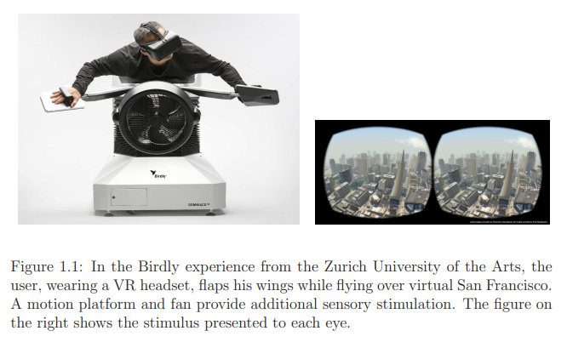
Example:1) A human having an experience of flying over virtual San Francisco by flapping his own wings (Figure 1.1); 2) a gerbil running on a freely rotating ball while exploring a virtual maze that appears on a projection screen around the mouse (Figure 1.2).
When an animal explores its environment, neural structures composed of place cells are formed that encode spatial information about its surroundings. Grid cells even encode locations in a manner similar to Cartesian coordinates. It has been shown that these neural structures may form in an organism, even when having a VR experience. In other words, our brains may form place cells for places that are not real!
The real world refers to the physical world that contains the user at the time of the experience, and the virtual world refers to the perceived world as part of the targeted VR experience.
Augmented reality (AR) refers to systems in which most of the visual stimuli are propagated directly through glass or cameras to the eyes, and some additional structures, such as text and graphics, appear to be superimposed onto the user’s world. The term mixed reality (MR) is sometimes used to refer to an entire spectrum that encompasses VR, AR, and ordinary reality.

Modern VR experiences
This section provides a quick overview of what people are doing with VR
systems.
1. Video games
People have dreamed of entering their video game worlds for decades. By 1982, this concept was already popularized by the Disney movie Tron.
Figure 1.6 shows several video game experiences in VR.
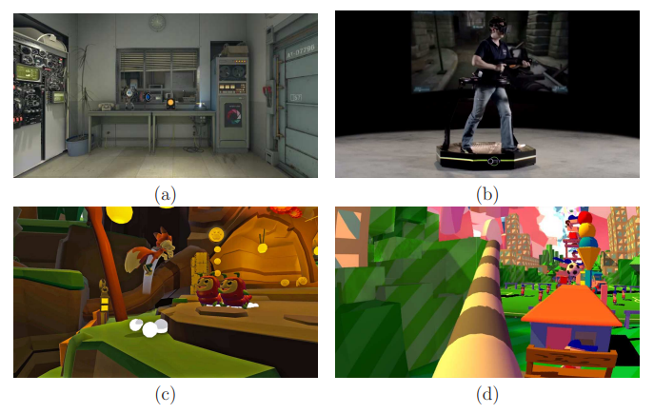
Figure 1.6(a) shows Valve’s Portal 2 for the HTC Vive headset.
Figure 1.6(b) shows The Virtuix Omni treadmill for walking through first-person shooter games. These two examples give the user a first-person perspective of their character.
By contrast, Figure 1.6(c) shows Lucky’s Tale, which instead
yields a comfortable third-person perspective as the user seems to float above the character that she controls. Figure 1.6(d) In the Dumpy game from DePaul University, the player appears to have a large elephant trunk. The purpose of the game is to enjoy this unusual embodiment by knocking things down with a swinging trunk.
Most gamers currently want to explore large, realistic worlds through an avatar.
2. Immersive cinema
Movie directors are entering a fascinating new era of film. Till now the concept is that cinematographer controls the camera viewpoint. In VR, viewers can look in any direction, and perhaps even walk through the scene. ie make the viewers feel like they are part of the scene.
- What should they be allowed to do?
- How do you make sure they do not miss part of the story?
- Should the story be linear, or should it adapt to the viewer’s actions?
- Should the viewer be a first-person character in the film, or a third-person observer who in invisible to the other characters?
- How can a group of friends experience a VR film together?
- When are animations more appropriate versus the capture of real scenes?
Ex:In 2015, Oculus Story Studio produced Emmy-winning Henry, an
immersive short story about an unloved hedgehog who hopes to make a new friend, the viewer.
Many simple extensions can be made without modifying the films. For example, in a movie about zombies, a few virtual zombies could enter the theater and start to chase you.
You can also have a social experience. Imagine having “movie night” with your friends from around the world, while you sit together in the virtual movie theater.
3.Telepresence
The first step toward feeling like we are somewhere else in the real world (Telepresence) is capturing a panoramic view of the remote environment. Google’s Street View and Earth apps already rely on the captured panoramic images from millions of locations around the world. Simple VR apps that query the Street View server directly enable to user to feel like he is standing in each of these locations, while easily being able to transition between nearby locations.
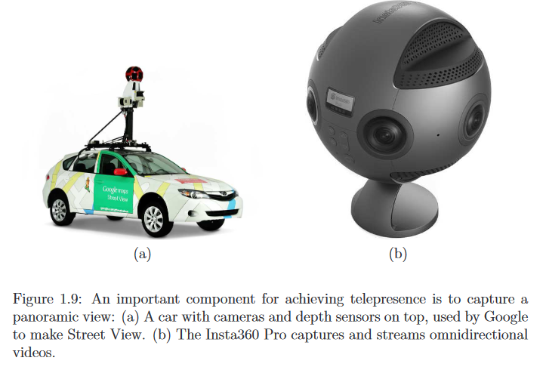
People can take video conferencing to the next level by feeling present at the remote location.
By connecting panoramic cameras to robots, the user is even allowed to move around in the remote environment.
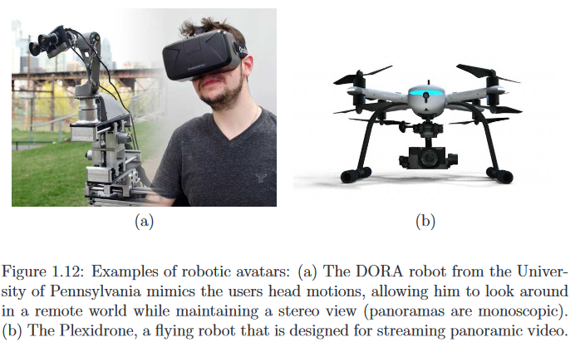
Current VR technology allows us to virtually visit far away places and interact in most of the ways that were previously possible only while physically present. This leads to improved opportunities for telecommuting to work. This could ultimately help reverse the urbanization trend.

4. Virtual societies
Whereas telepresence makes us feel like we are in another part of the physical world, VR also allows us to form entire societies that remind us of the physical world, but are synthetic worlds that contain avatars connected to real people.
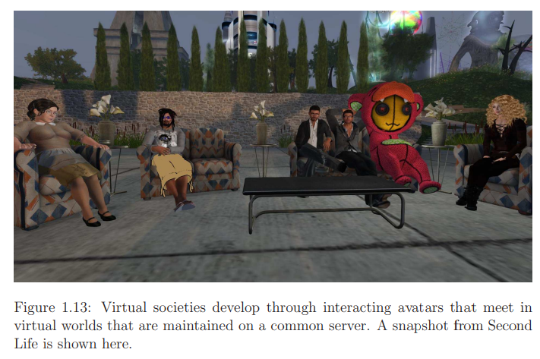
Figure 1.13 shows a Second Life scene in which people interact in a fantasy world through avatars; such experiences were originally designed to view on a screen but can now be experienced through VR. Groups of people could spend time together in these spaces for a variety of reasons, including common special interests, educational goals, or simply an escape from ordinary life.
5. Empathy
The world continues to struggle with acceptance and equality for others of different race, religion, age, gender, sexuality, social status, and education, while the greatest barrier to progress is that most people cannot fathom what it is like to have a different identity. The first-person perspective provided by VR is a powerful tool for causing people to feel empathy for someone else’s situation.
In 2014, BeAnotherLab, an interdisciplinary collective, made “The Machine to Be Another” where you can swap bodies with the other gender. Each person wears a VR headset that has cameras mounted on its front. Each therefore sees the world from the approximate viewpoint of the other person. They were asked to move their hands in coordinated motions so that they see their new body moving appropriately.
6.Education
In engineering, mathematics, and the sciences, VR offers the chance to visualize geometric relationships in difficult concepts or data that are hard to interpret. Furthermore, VR is naturally suited for practical training if the real environment is costly to provide or poses health risks. One of the earliest and most common examples of training in VR is flight simulation. The user sits in a physical cockpit while being surrounded by displays that show the environment. Other examples include fire fighting, nuclear power plant safety, search-and-rescue, military operations, and medical procedures.
Beyond these common uses of VR, perhaps the greatest opportunities for VR education lie in the humanities, including history, anthropology, and foreign language acquisition. Consider the difference between reading a book on the Victorian era in England and being able to roam the streets of 19th-century London, in a simulation.
Fascinating possibilities exist for either touring physical museums through a VR interface or scanning and exhibiting artifacts directly in virtual museums. These examples fall under the heading of digital heritage.
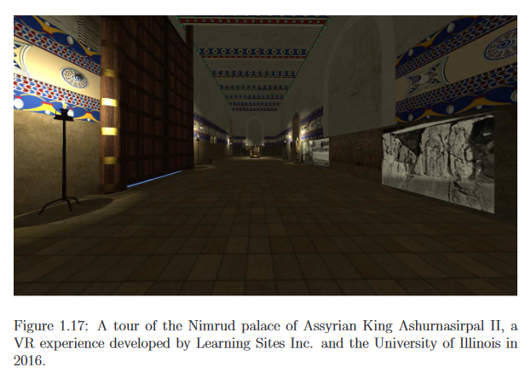
7. Virtual Prototyping
In the real world, we build prototypes to understand how a proposed design feels or functions. Virtual prototyping enables designers to inhabit a virtual world that contains their prototype .They can quickly interact with it and make modifications. They also have opportunities to bring clients into their virtual world so that they can communicate their ideas. Imagine you want to remodel your kitchen. You could construct a model in VR and then explain to a contractor exactly how it should look. Virtual prototyping in VR has important uses in many businesses, including real estate, architecture, and the design of aircraft, spacecraft, cars, furniture, clothing, and medical instruments.
8.Health care
Although health and safety are challenging VR issues, the technology can also help to improve our health.
There is an increasing trend toward distributed medicine, in which doctors train people to perform routine medical procedures in remote communities around the world. Doctors can provide guidance through telepresence, and also use VR technology for training.
In another use of VR, doctors can immerse themselves in 3D organ models that were generated from medical scan data. This enables them to better plan and prepare for a medical procedure by studying the patient’s body shortly before an operation.
They can also explain medical options to the patient or his family so that they may make more informed decisions.
In yet another use, VR can directly provide therapy to help patients. Examples include overcoming phobias and stress disorders through repeated exposure, improving or maintaining cognitive skills in spite of aging, and improving motor skills to overcome balance, muscular, or nervous system disorders.
VR systems could also one day improve longevity by enabling aging people to virtually travel, engage in fun physical therapy, and overcome loneliness by connecting with family and friends through an interface that makes them feel present and included in remote activities.
9.Augmented and Mixed reality
Augmented reality (AR) is an interactive experience that combines the real world and computer-generated content. In the AR experience, you can see a composite view of physical or real-world elements and digital elements.
Mixed reality (MR) is a technology that allows not only the superposition of digital elements into the real-world environment but also their interaction. In the MR experience, the user can see and interact with both the digital elements and the physical ones.
Sometimes AR and MR re referred in the same sense.
In many applications, it is advantageous for users to see the live, real world with some additional graphics superimposed to enhance its appearance; see Figure 1.20. This has been referred to as augmented reality or mixed reality.
Imagine a factory environment in which workers see identifying labels above parts that need to assembled, or they can look directly inside of a machine to determine potential replacement parts.
By placing text, icons, and other graphics into the real world, the user could leverage the power of the Internet to help with many operations such as navigation, social interaction, and mechanical maintenance.
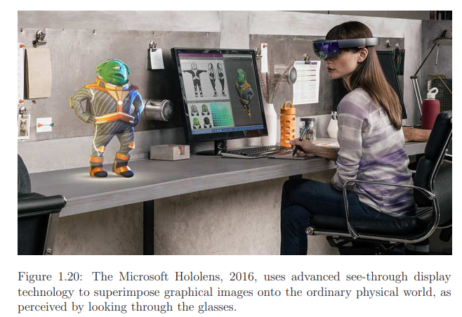
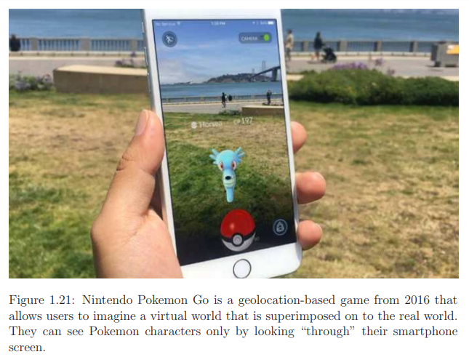
10.New Human Experiences
Through telepresence, people can try experiences through the eyes of robots or other people. However, we can go further by giving people experiences that are impossible (or perhaps deadly) in the real world.
The Birdly experience of human flying (Figure 1.1) was an excellent example.
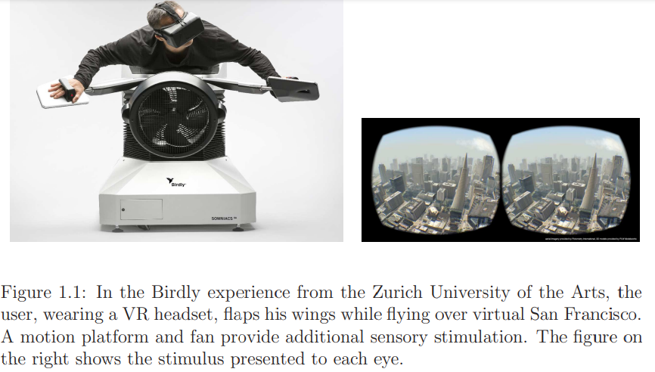
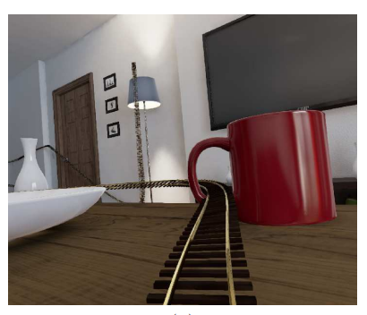
In 2014, Epic Games created a wild roller coaster ride through virtual living room.

History
How did we arrive to VR as it exists today?
1.Staring at rectangles
Recorded history begins with people painting on cave walls to express the happenings of the hunt and sharing stories to chronicle the history of a community or tribe. It then progressed through painting from the European Middle Ages. There is much greater detail in the newer painting, leaving less to the imagination; however, the drawing perspective is comically wrong. Some people seem short relative to others, rather than being further away(1.23 b). Later people began to paint pictures that look like 3D(1.23 c). By the 19th century, many artists had grown tired of such realism and started the controversial impressionist movement (1.23 d).
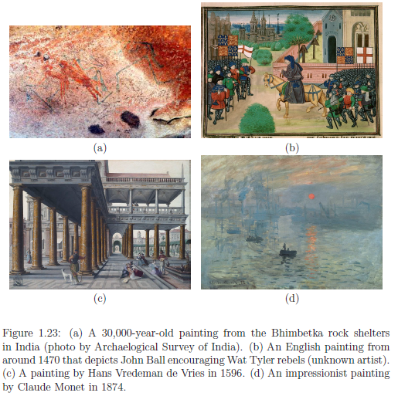
2. Moving Pictures
The phenomenon of stroboscopic apparent motion is the basis for what we call movies or motion pictures today.
Flipping quickly through a sequence of pictures gives the illusion of motion, even at a rate as low as two pictures per second. Above ten pictures per second, the motion even appears to be continuous, rather than perceived as individual pictures. One of the earliest examples of this effect is the race horse movie created by Eadward Muybridge in 1878.
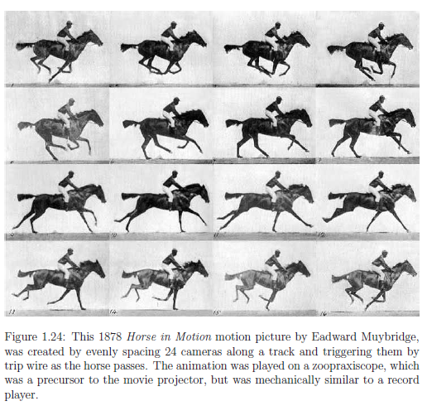
Motion picture technology quickly improved, and by 1896, a room full of spectators in a movie theater screamed in terror as a short film of a train pulling into a station convinced them that the train was about to crash into them (Figure 1.25(a)). There was no audio track.
In 1902, viewers were inspired by a Journey to the Moon (Figure 1.25(b)), but by 2013, an extremely high degree of realism seemed necessary to keep viewers believing (Figure 1.25(c) and 1.25(d)).
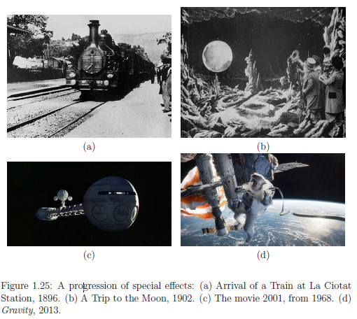
Even within the realm of animations, a similar trend has emerged as with motion pictures in general. ie motion picture audiences have been willing to accept lower degrees of realism. Starting from simple line drawings in 1908 with Fantasmagorie (Figure 1.26(a)), greater detail appears in 1928 with the introduction of Mickey Mouse(Figure 1.26(b)). By 2003, animated films achieved a much higher degree of realism (Figure 1.26(c)); however, excessively simple animations have also enjoyed widespread popularity (Figure 1.26(d)).
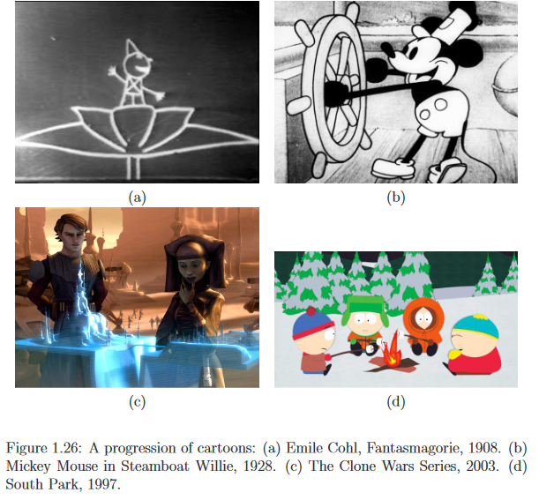
3. Towards convenience and portability
Further motivations for accepting lower levels of realism are cost and portability. Families were willing to gather in front of a television to watch free broadcasts in their homes, even though they could go to theaters and watch high-resolution, color, panoramic, and 3D movies at the time. Such tiny, blurry, black-and-white television sets seem comically intolerable with respect to our current expectations.
The next level of portability is to carry the system around with you. Thus, the progression is from:
1) having to go somewhere to watch it, to
2) being able to watch it in your home, to
3) being able to carry it anywhere.
Whether pictures, movies, phones, computers, or video games, the same progression continues. We can therefore expect the same for VR systems.
4.Video Games
Motion pictures yield a passive, third-person experience, in contrast to video games which are closer to a first-person experience.
Most VR experiences involve another crucial component: interaction. If the sensory stimulation does not depend on actions taken by the organism,
then the VR system is called open-loop; otherwise, it is closed-loop. (In the case of closed-loop VR, the organism has partial control over the sensory stimulation, which could vary as a result of body motions, including eyes, head, hands, or legs. Other possibilities include voice commands, heart rate, body temperature, and skin conductance (are you sweating?).). Video games are an important step toward closed-loop VR, whereas motion pictures are open-loop. In case of video games, we can see a trend from simplicity to improved realism and then back to simplicity. The earliest games, such as Pong and Donkey Kong, left much to the imagination. First-person shooter (FPS) games such as Doom gave the player a first-person perspective and launched a major campaign over the following decade toward higher quality graphics and realism. Assassin’s Creed shows a typical scene from a modern, realistic video game. At the same time, wildly popular games have emerged by focusing on simplicity. Angry Birds looks reminiscent of games from the 1980s, and Minecraft
allows users to create and inhabit worlds composed of course blocks. Note that reduced realism often leads to simpler engineering requirements.
More realistic game might require a powerful PC and graphics card, whereas simpler games would run on a basic smartphone.
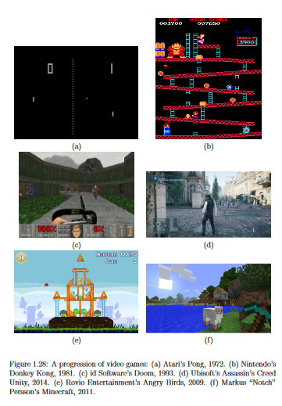
5. Beyond staring at a rectangle
Two important steps come next:
1) Presenting a separate picture to each eye to induce a “3D” effect.
2) Increasing the field of view so that the user is not distracted by the stimulus boundary.
One way our brains infer the distance of objects from our eyes is by stereopsis. Information is gained by observing and matching features in the world that are visible to both the left and right eyes. The differences between their images on the retina yield cues about distances. The first experiment that showed the 3D effect of stereopsis was performed in 1838 by Charles Wheatstone in a system called the stereoscope (Figure 1.29(a)). By the 1930s, a portable version became a successful commercial product known to this day as the View-Master (Figure 1.29(b)). Pursuing this idea further led to Sensorama, which added motion pictures, sound, vibration, and even smells to the experience (Figure 1.29(c)).
Stereopsis was achieved when participants wore special glasses that select a different image for each eye using polarized light filters. This popularized 3D movies, which are viewed the same way in the theaters today.
Another way to increase the sense of immersion and depth is to increase the field of view. The Cinerama system from the 1950s offered a curved, wide field of view that is similar to the curved, large LED (Light-Emitting Diode) displays offered today (Figure 1.29(d)). Along these lines, we could place screens all around us. This idea led to one important family of VR systems called the CAVE, which was introduced in 1992 at the University of Illinois (Figure 1.30(a)). The user enters a room in which video is projected onto several walls. The CAVE system also offers stereoscopic viewing by presenting different images to each eye using polarized light and special glasses. Often, head tracking is additionally performed to allow viewpoint-dependent video to appear on the walls.
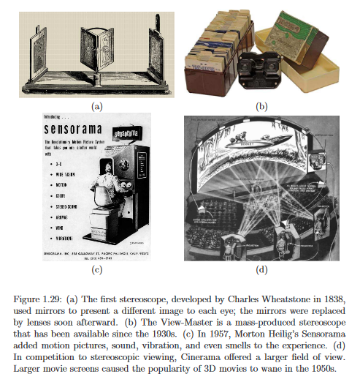
6. VR headsets
An important step for VR was taken in 1968 with the introduction of Ivan Sutherland’s Ultimate Display, which leveraged the power of modern displays and computers (Figure 1.30(b)). He constructed what is widely considered to be the first VR headset. As the user turns his head, the images presented on the screen are adjusted to compensate so that the virtual objects appear to be fixed in space. To make an object appear to be stationary while you move your sense organ, the device producing the stimulus must change its output to compensate for the motion. This requires sensors and tracking systems to become part of the VR system. Commercial VR headsets started appearing in the 1980s with Jaron Lanier’s company VPL, thereby popularizing the image of goggles and gloves; Figure 1.30(c). In the 1990s, VR-based video games appeared in arcades (Figure 1.30(d)) and in home units (Figure 1.30(e). The experiences were not compelling or comfortable enough to attract mass interest. However, the current generation of VR headset leverages the widespread availability of high resolution screens and sensors, due to the smartphone industry, to offer lightweight, low-cost, high-field-of-view headsets, such as the Oculus Rift (Figure 1.30(f)). This has greatly improved the quality of VR experiences.
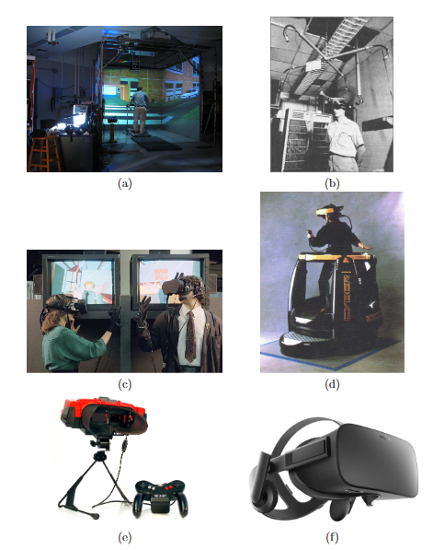
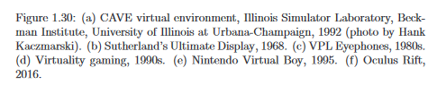
7. Bringing people together
We use formats such as a live theater performance, a classroom, or a lecture hall for a few people to communicate with or entertain a large audience. In the context of games, early Multi-User Dungeons (MUDs) grew into Massively Multiplayer Online Games (MMORPGs) that we have today. In the context of education, the PLATO system from the University of Illinois was the first computer-assisted instruction system, which included message boards, instant messaging, screen sharing, chat rooms, and emoticons. This was a precursor to many community-based,
on-line learning systems, such as the Khan Academy and Coursera. The largest amount of online social interaction today occurs through Facebook apps, which involve direct communication through text along with the sharing of pictures, videos, and links.
Returning to VR, we can create avatar representations of ourselves and “live” together in virtual environments, as is the case with Second Life and Opensimulator (Fig1.31).
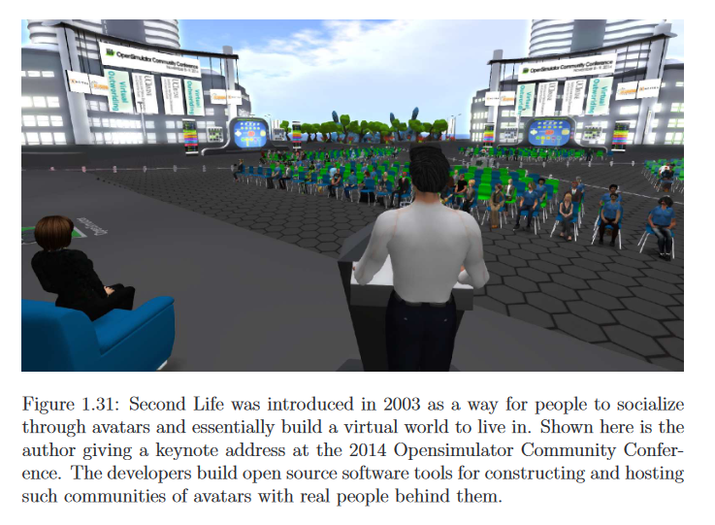

Virtual Reality Systems

The creation of a virtual reality system requires the integration of multiple components. These components include the system hardware, underlying support software for linking the display and input hardware together, the virtual world content with which the user will interact, and a user interface design that provides a suitable means for appropriate user interactions.
Hardware used in virtual reality systems can be roughly categorized as display devices, input devices that a user consciously activates, and input devices that monitor the user, along with the computer that supports the modeling and rendering of the virtual world.
Visual display paradigm include stationary(eg:CAVE, wall displays, and table or desk displays), head-based(Helmet-mounted display, mechanical arm-mounted display, Binocular Omni-Orientation Monitor (BOOM)) and hand-based display.They have its own specific benefits and disadvantages.They can provide display as either stereoscopic images, or monoscopic.
System hardware also includes Aural displays which includes devices like loudspeakers and headphones and haptic dislays(touch).
Use of other sensory displays has also been done. Of these the vestibular sense (the sense of balance) is the most common. In fact, it has been a very common form of display for flight simulation for decades. Olfactory display (smell) has been experimented with sparingly, and computer-controlled display of gustation (taste) is virtually nonexistent.
Input and user tracking device include position sensors, electromagnetic tracking systems, mechanical tracking systems, ultrasonic tracking systems, optical tracking systems, inertial and gyroscopic tracking systems, neural and muscular tracking systems etc.
A variety of software components must also be integrated to enable cogent VR experiences. Such software ranges from low-level libraries for simulating events, rendering display imagery, interfacing with I/O devices, and creating and altering object descriptions, to completely
encapsulated “turnkey” systems that allow one to begin running an immersive experience with no programming effort.
VR experiences obey some programmed laws of nature eg:gravity, prevent users from walking through walls, a flower could be plucked with a grasping gesture and when released, fall to the ground, for a bee to fly, it would have to flap its wings etc. Some VR experience have fantastic behaviour also. Eg:users having “x-ray” vision abilities to see through objects or to see the interior structure of an object, give the user the ability to move heavy objects such as walls and furniture in an architectural (or game-world) design application, and walk through walls.
Rendering libraries convert the form of the world from the internal computer database to what the user experiences. Appropriate rendering algorithms are used for this. For example, in a typical graphics library, along with the ability to render basic forms by specifying the vertices and colors of polygons, the programmer is also given options to add lighting elements, and overlay photographs onto polygons to make them appear more realistic. Also, such libraries can support higher level graphical functions like hierarchical object descriptions (“scenegraphs”) and collision detection.
The paramount task of this VR library is to acquire the necessary information about the participant. This is done by interfacing with tracking and other input hardware. Information from the various sensors is integrated and provides the necessary parameters to the rendering systems. For example, the graphics (and also 3D audio) rendering process requires knowledge of the user’s head position to give the proper visual/soundscape. Another critical requirement of the library is to operate in “real time.” It must perform all the input, simulation, and rendering functions at a rate that makes the world appear to be “real” by immediately responding to the participant’s actions. Using multiple processing units on VR systems can help to achieve such “real time” responsiveness. Therefore, VR libraries typically include the ability to perform multiple tasks at once.
The creation of a virtual reality experience also requires the use of various software (Ancillary softwares)in addition to the software required during the presentation of the experience. Examples of such tools include modeling software to aid in the construction of the form of the objects that inhabit the world; sound editing software to construct sound clips that will be heard in the experience, and image processing software to create appropriate texture maps. Independent user interface libraries might also be linked with a VR experience to allow the operator to control parameters of the experience, for example a mouse-controlled widget panel. File formats such as VRML (a format for describing three-dimensional computer graphics objects and spaces) and other standard object formats also play an important role in the creation of virtual reality worlds.

Hardware

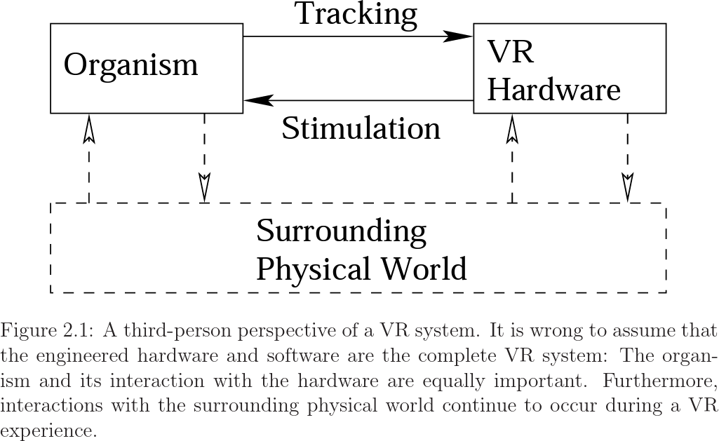
The hardware produces stimuli that override the senses of the user. Tracking was needed to adjust the stimulus based on human motions. The VR hardware accomplishes this by using its own sensors, thereby tracking motions of the user. Head tracking is the most important, but tracking also may include button presses, controller movements, eye movements, or the movements of any other body parts. Finally, it is also important to consider the surrounding physical world as part of the VR system.
In spite of stimulation provided by the VR hardware, the user will always have other senses that respond to stimuli from the real world. She also has the ability to change her environment through body motions. The VR hardware might also track objects other than the user, especially if interaction with them is part of the VR experience. Through a robotic interface, the VR hardware might also change the real world. One example is teleoperation of a robot through a VR interface.

1.Sensors and sense organs
How is information extracted from the physical world?
In engineering, a transducer refers to a device that converts energy from one form to another. A sensor is a special transducer that converts the energy it receives into a signal for an electrical circuit. This may be an analog or digital signal, depending on the circuit type. A sensor typically has a receptor that collects the energy for conversion. Organisms work in a similar way. The “sensor” is called a sense organ, with common examples being eyes and ears. Because our “circuits” are formed from interconnected neurons, the sense organs convert energy into neural impulses.

2.Configuration space of sense organs
As the user moves through the physical world, his sense organs move along with him. Furthermore, some sense organs move relative to the body skeleton, such as our eyes rotating within their sockets. Each sense organ has a configuration space, which corresponds to all possible ways it can be transformed or configured. The most important aspect of this is the number of degrees of freedom or DOFs of the sense organ. A rigid object that moves through ordinary space has six DOFs. Three DOFs correspond to its changing position in space: 1) closer-further motion 2) side-to-side motion, and 3) vertical motion . The other three DOFs correspond to possible ways the object could be rotated; in other words, exactly three independent parameters are needed to specify how the object is oriented. These are called yaw, pitch, and roll.
As an example, consider your left ear. As you rotate your head or move your body through space, the position of the ear changes, as well as its orientation. This yields six DOFs. The same is true for your right eye, but it also capable of rotating independently of the head. Keep in mind that our bodies have many more degrees of freedom, which affect the configuration of our sense organs. A tracking system may be necessary to determine the position and orientation of each sense organ that receives artificial stimuli.

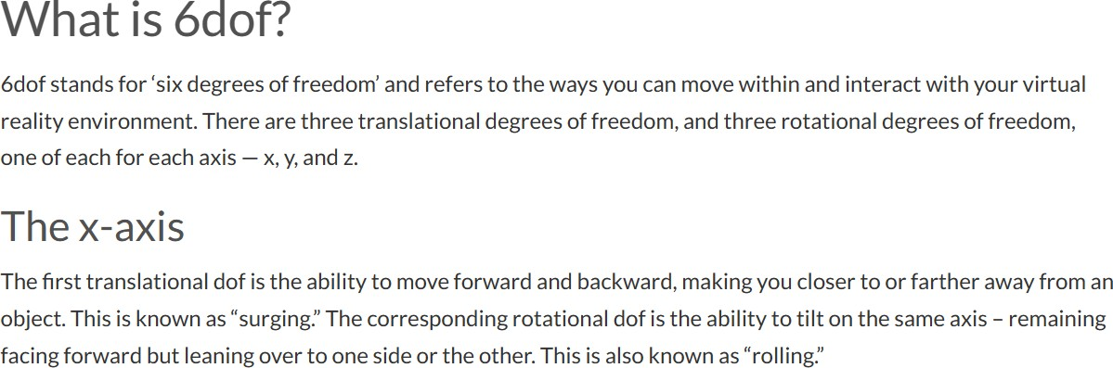
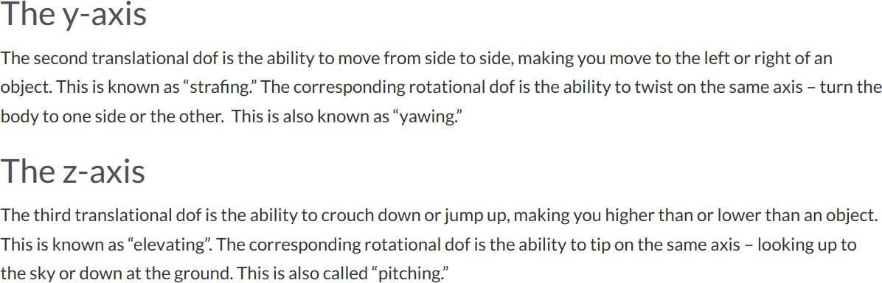

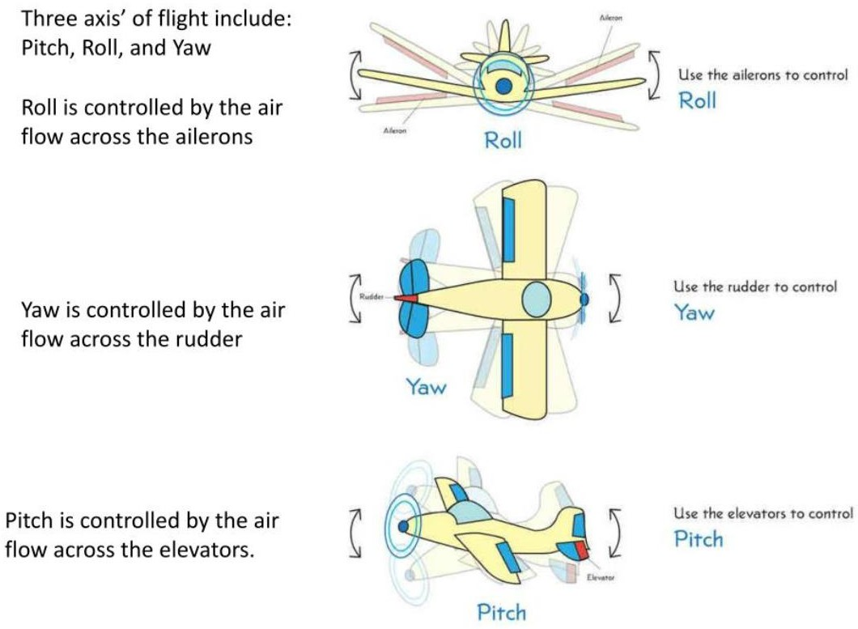

3.An abstract view
Figure 2.2 illustrates the normal operation of one of our sense organs without interference from VR hardware. The brain controls its configuration, while the sense organ converts natural stimulation from the environment into neural impulses that are sent to the brain.
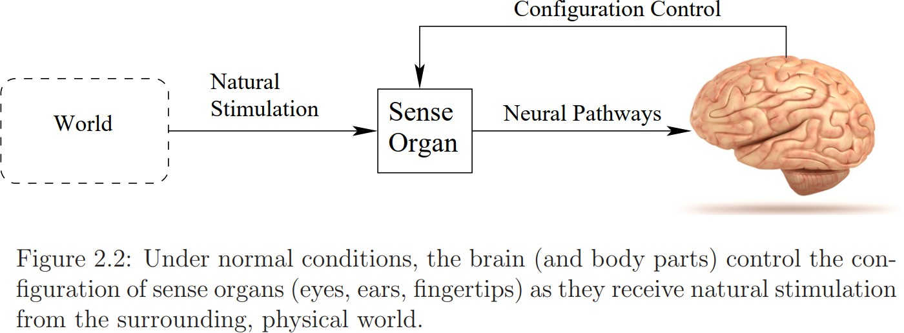

Figure 2.3 shows how it appears in a VR system.
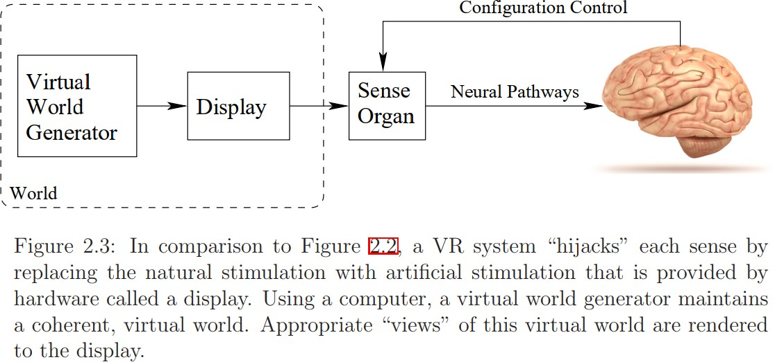
A Virtual World Generator (VWG) runs on a computer and produces “another world”, which could be many possibilities, such as a pure simulation of a synthetic world, a recording of the real world, or a live connection to another part of the real world. The human perceives the virtual world through each targeted sense organ using a display, which emits energy that is specifically designed to mimic the type of stimulus that would appear without VR. The process of converting information from the VWG into output for the display is called rendering. In the case of human eyes, the display might be a smartphone screen or the screen of a video projector. In the case of ears, the display is referred to as a speaker. (A display need not be visual, even though this is the common usage in everyday life.) If the VR system is effective, then the brain is hopefully “fooled” in the sense shown in Figure 2.4. The user should believe that the stimulation of the senses is natural and comes from a plausible world, being consistent with at least some past experiences.
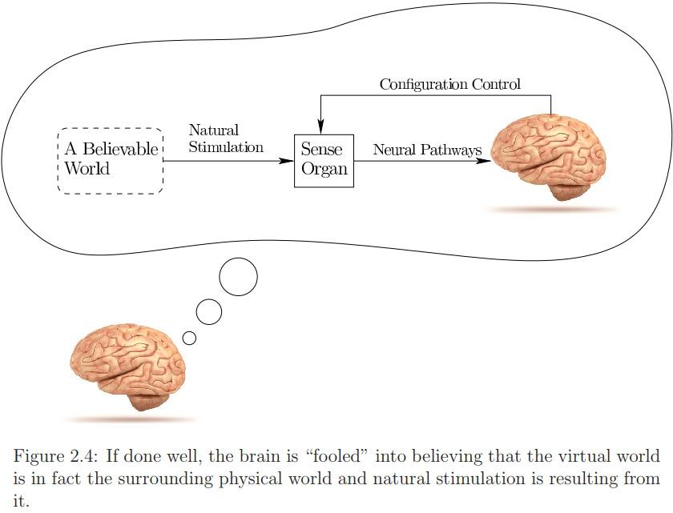

4.Aural: world-fixed vs. user-fixed
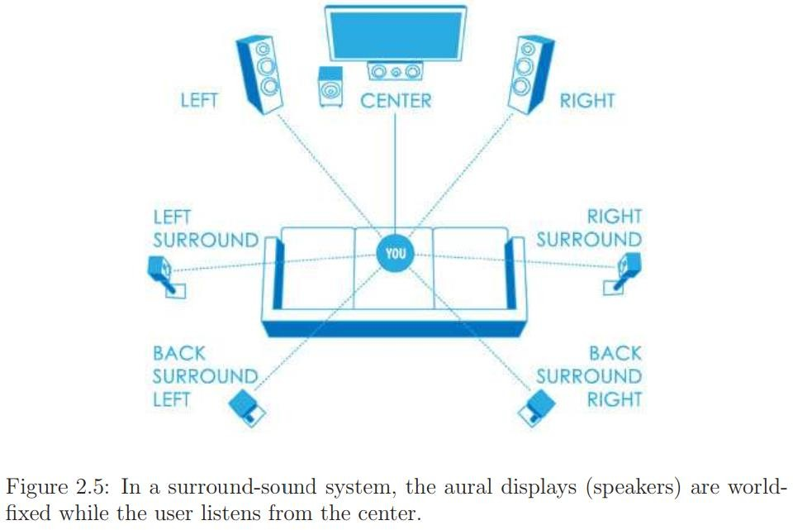

Figure 2.5 shows the speaker setup and listener location for a Dolby 7.1 Surround Sound theater system, which could be installed at a theater or a home family room. Seven speakers distributed around the room periphery generate most of the sound, while a subwoofer (the “1” of the “7.1”) delivers the lowest frequency components. The aural displays are therefore world-fixed. Compare this to a listener wearing headphones, as shown in Figure 2.6. In this case, the aural displays are user-fixed.
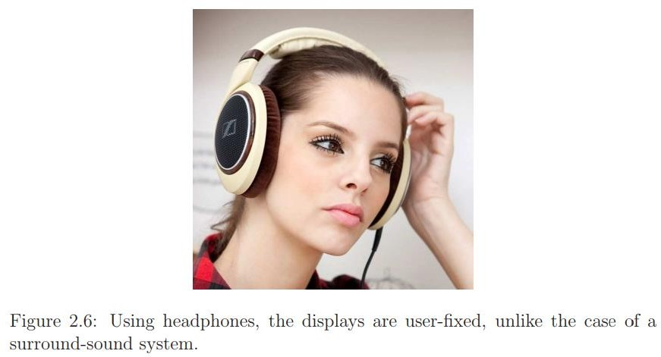

What are the key differences?
- In the surround-sound system, the generated sound (or stimulus) is far away from the ears, whereas it is quite close for the headphones.
- One implication of the difference in distance is that much less power is needed for the headphones to generate an equivalent perceived loudness level compared with distant speakers.
- Another implication based on distance is the degree of privacy allowed by the wearer of headphones. A surround-sound system at high volume levels could generate a visit by angry neighbors.
- Wearing electronics on your head could be uncomfortable over long periods of time, causing a preference for surround sound over headphones.
- Several people can enjoy the same experience in a surround-sound system (although they cannot all sit in the optimal location). Using headphones, they would need to split the audio source across their individual headphones simultaneously.
- They are likely to have different costs, depending on the manufacturing difficulty and available component technology. At present, headphones are favored by costing much less than a set of surround-sound speakers (although one can spend a large amount of money on either).
All of these differences carry over to VR systems. While listening to music, close your eyes and imagine you are at a live performance with the artists surrounding you. Where do you perceive the artists and their instruments to be located? Are they surrounding you, or do they seem to be in the middle of your head? Using headphones, it is most likely that they seem to be inside your head. In a surround-sound system, if recorded and displayed properly, the sounds should seem to be coming from their original locations well outside of your head. In VR if you want to preserve your perception of where sounds are coming from, then headphones would need to take into account the configurations of your ears in space to adjust the output accordingly. For example, if you nod your head back and forth in a “no” gesture, then the sound being presented to each ear needs to be adjusted so that the simulated sound source is rotated in the opposite direction. In the surround-sound system, the speaker does not follow your head and therefore does not need to rotate.

5.Visual: world-fixed vs. user-fixed
Figure 2.7(a) shows a CAVE system, which parallels the surround-sound system in many ways. The user again sits in the center while displays around the periphery present visual stimuli to his eyes. The speakers are replaced by video screens. Figure 2.7(b) shows a user wearing a VR headset, which parallels the headphones.
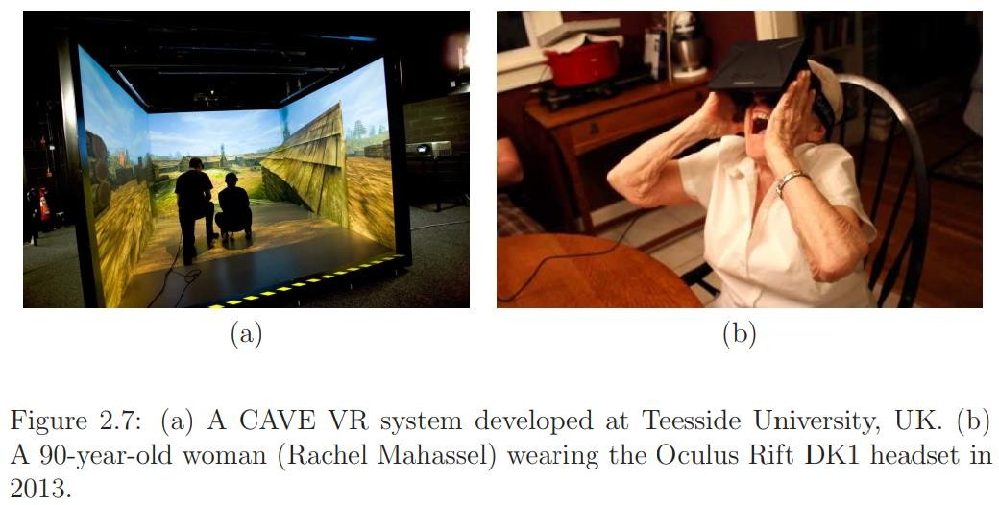

Suppose the screen in front of the user’s eyes shows a fixed image in the headset. If the user rotates his head, then the image will be perceived as being attached to the head. This would occur, for example, if you rotate your head while using the View-master. If you would like to instead perceive the image as part of a fixed world around you, then the image inside the headset must change to compensate as you rotate your head. The surrounding virtual world should be counter-rotated.So it becomes a significant engineering challenge to estimate the amount of head and eye movement that has occurred and apply the appropriate transformation in a timely and accurate manner.
If this is not handled well, then users could have poor or unconvincing experiences. Worse yet, they could fall prey to VR sickness. This is one of the main reasons why the popularity of VR headsets waned in the 1990s. The component technology was not good enough yet. Fortunately, the situation is much improved at present.
6. The hardware components of VR systems are conveniently classified as:
- Displays (output): Devices that each stimulate a sense organ.
- Sensors (input): Devices that extract information from the real world.
- Computers: Devices that process inputs and outputs sequentially.

Displays
A display generates stimuli for a targeted sense organ. Vision is our dominant sense, and any display constructed for the eye must cause the desired image to be formed on the retina. For CAVE systems, some combination of digital projectors and mirrors is used. Due to the plummeting costs, an array of large-panel displays may alternatively be employed. For headsets, a smartphone display can be placed close to the eyes and brought into focus using one magnifying lens for each eye. Screen manufacturers are currently making custom displays for VR headsets by leveraging the latest LED display technology from the smartphone industry. Some are targeting one display per eye with frame rates above 90Hz and over two megapixels per eye.
Sound is displayed to the ears using classic speaker technology. Bone conduction methods may also be used, which vibrate the skull and propagate the waves to the inner ear; this method appeared in Google Glass.
For the sense of touch, there are haptic displays. Two examples are pictured in Figure 2.8. Haptic feedback can be given in the form of vibration, pressure, or temperature.
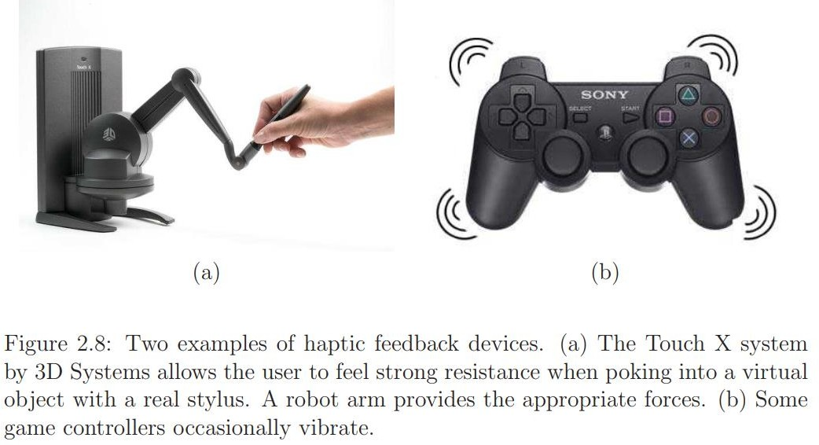

Sensors
For visual and auditory body-mounted displays, the position and orientation of the sense organ must be tracked by sensors to appropriately adapt the stimulus. The orientation part is usually accomplished by an inertial measurement unit or IMU. The main component is a gyroscope, which measures its own rate of rotation; the rate is referred to as angular velocity and has three components. Measurements from the gyroscope are integrated over time to obtain an estimate of the cumulative change in orientation. The resulting error, called drift error, would gradually grow unless other sensors are used. To reduce drift error, IMUs also contain an accelerometer and possibly a magnetometer. Over the years, IMUs have gone from existing only as large mechanical systems in aircraft and missiles to being tiny devices inside of smartphones; see Figure 2.9. Due to their small size, weight, and cost, IMUs can be easily embedded in wearable devices. They are one of the most important enabling technologies for the current generation of VR headsets and are mainly used for tracking the user’s head orientation.
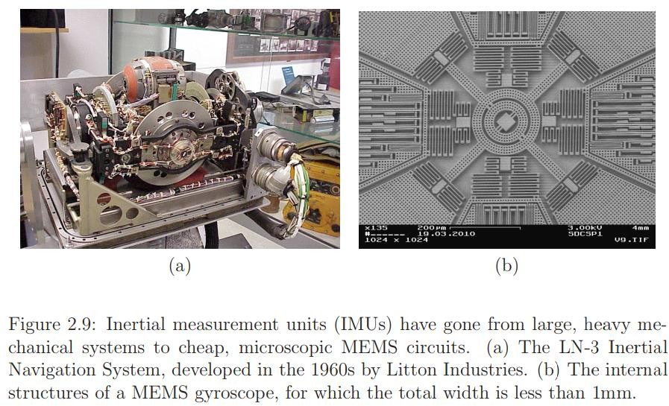
Digital cameras provide another critical source of information for tracking systems. Like IMUs, they have become increasingly cheap and portable due to the smartphone industry, while at the same time improving in image quality. Cameras enable tracking approaches that exploit line-of-sight visibility. The idea is to identify features or markers in the image that serve as reference points for an moving object or a stationary background. Such visibility constraints severely limit the possible object positions and orientations. Standard cameras passively form an image by focusing the light through an optical system, much like the human eye. Once the camera calibration parameters are known, an observed marker is known to lie along a ray in space. Cameras are commonly used to track eyes, heads, hands, entire human bodies, and any other objects in the physical world. One of the main challenges at present is to obtain reliable and accurate performance without placing special markers on the user or objects around the scene.
As opposed to standard cameras, depth cameras work actively by projecting light into the scene and then observing its reflection in the image. This is typically done in the infrared (IR) spectrum so that humans do not notice; see Figure 2.10. In addition to these sensors, we rely heavily on good-old mechanical switches and potientiometers to create keyboards and game controllers. An optical mouse is also commonly used. One advantage of these familiar devices is that users can rapidly input data or control their characters by leveraging their existing training.
A disadvantage is that they might be hard to find or interact with if their faces are covered by a headset.

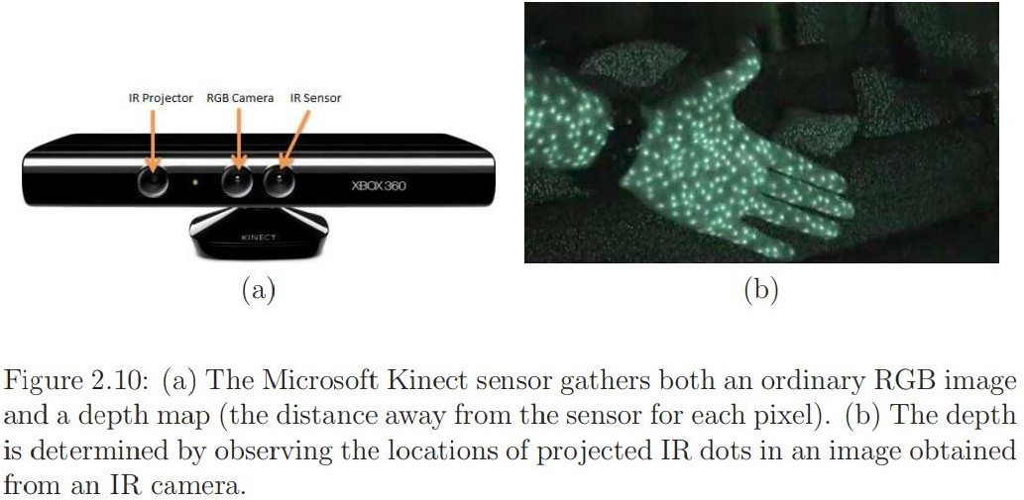

Computers
A computer executes the virtual world generator (VWG). If a separate PC is needed to power the system, then fast, reliable communication must be provided between the headset and the PC. This connection is currently made by wires, leading to an awkward tether; current wireless speeds are not sufficient. As you have noticed, most of the needed sensors exist on a smartphone, as well as a moderately powerful computer. Therefore, a smartphone can be dropped into a case with lenses to provide a VR experience with little added costs (Figure 2.11).
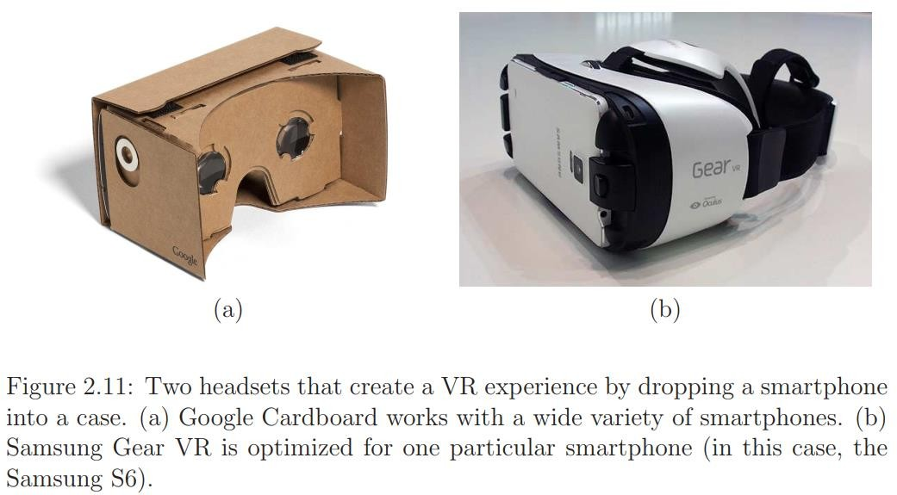
The limitation, though, is that the VWG must be simpler than in the case of a separate PC so that it runs on less powerful computing hardware. In the near future, we expect to see wireless, all-in one headsets that contain all of the essential parts of smartphones for delivering VR experiences.
In addition to the main computing systems, specialized computing hardware may be utilized. Graphical processing units (GPUs) have been optimized for quickly rendering graphics to a screen and they are currently being adapted to handle the specific performance demands of VR. Also, a display interface chip converts an input video into display commands. Finally, microcontrollers are frequently used to gather information from sensing devices and send them to the main computer using standard protocols, such as USB.
Figure 2.12 shows the hardware components for the Oculus Rift DK2, which became available in late 2014. In the lower left corner, you can see a smartphone screen that serves as the display. Above that is a circuit board that contains the IMU, display interface chip, a USB driver chip, a set of chips for driving LEDs on the headset for tracking, and a programmable microcontroller. The lenses, shown in the lower right, are placed so that the smartphone screen appears to be “infinitely far” away, but nevertheless fills most of the field of view of the user. The upper right shows flexible circuits that deliver power to IR LEDs embedded in the headset (they are hidden behind IR-transparent plastic). A camera is used for tracking, and its parts are shown in the center.

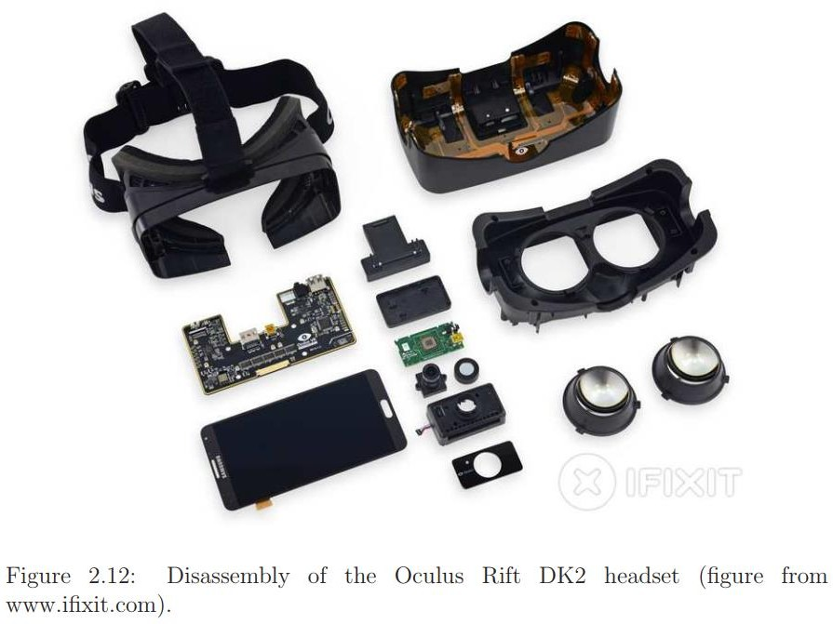

Software
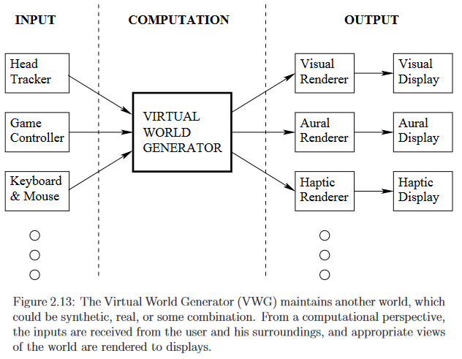

What software components are needed to produce a VR experience? Figure 2.13 presents a high-level view that highlights the central role of the Virtual World Generator (VWG). The VWG receives inputs from low-level systems that indicate what the user is doing in the real world. A head tracker provides timely estimates of the user’s head position and orientation. Keyboard, mouse, and game controller events arrive in a queue that are ready to be processed. The key role of the VWG is to maintain enough of an internal “reality” so that renderers can extract the
information they need to calculate outputs for their displays.
1. Laws of nature —simulation code
Many VR experiences have some programmed laws of nature that govern the behaviors and interactions carried out by the objects in the world. The exception to this is the case where the only interaction possible is changing the user’s viewpoint relative to the objects in the world. In this case, the user cannot manipulate the objects but only look at and work around them. One option for “world simulation ” is to merely allow several explicit cases of behavior to be executed under specific conditions. For example, in an architectural walk-through, the system may prevent
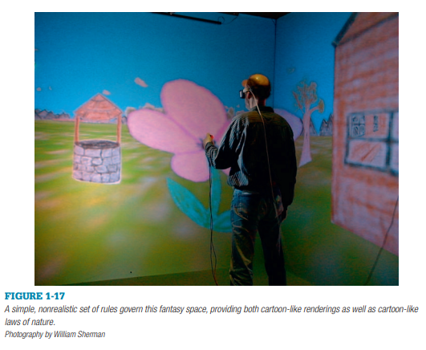
users from walking through walls, and constrain users ’ vertical movement to be as if they were walking on the floor surfaces. More advanced simulations can have global behaviors such as gravity, plus individual rules that apply only to specific objects. For example, a bee could be given a rule that allows it to fly in search of a flower, gather pollen, and then return to the hive. On the other hand, a flower could be plucked with a grasping gesture and when released, fall to the ground. Other application simulations strive to more closely mimic the real world by adhering to mathematical descriptions of real physics. So, for a bee to fl y, it would have to flap its wings sufficiently rapidly to generate the needed lift, and orient itself properly to send it in the desired direction. Given that in a virtual reality experience there is no requirement that the world follow the laws of the real world, it is possible to give objects fantastic behaviors. Such behaviors might be to give the user “x-ray ” vision abilities to see through objects or to see the interior structure of an object. Another possibility is to give the user the ability to move heavy objects such as walls and furniture in an architectural (or game-world) design application, and walk through walls.
The concept of world-physics also applies to how multiple users sharing the same world can interact and communicate with one another. Simple implementations of behaviors for collaboration might include representations of the other users (their “avatars ”), and perhaps also an audio channel that allows everyone to communicate verbally.
2 .Rendering libraries
Rendering libraries convert the form of the world from the internal computer database to what the user experiences. The rendering library must include the appropriate rendering algorithms for whatever sense is to be portrayed. Visual images produced from graphics rendering libraries are perhaps the most common of this class of software; however, such libraries have also been developed (and used in VR) for other senses, such as hearing and touch. These libraries generally include features to render the basic elements of a “scene” along with features to enrich the display. For example, in a typical graphics library, along with the ability to render basic forms by specifying the vertices and colors of polygons, the programmer is also given options to add lighting elements, and overlay photographs onto polygons to make them appear more realistic. Also, such libraries can support higher level graphical functions like hierarchical object descriptions ( “scenegraphs”) and collision detection.
3 VR libraries
A complete virtual reality system is not comprised merely of rendering sensory outputs, but rather rendering appropriate outputs depending on the user’s current position and actions. The paramount task of this VR library is to acquire the necessary information about the participant. This is done by interfacing with tracking and other input hardware. Information from the various sensors is integrated and provides the necessary parameters to the rendering systems. For example, the graphics (and also 3D audio) rendering process requires knowledge of the user’s head position to give the proper visual/soundscape. Another critical requirement of the library is to operate in “real time. ” It must perform all the input, simulation, and rendering functions at a rate that makes the world appear to be “real” by immediately responding to the participant’s actions. Using multiple processing units on VR systems can help to achieve such “real time ” responsiveness. Therefore, VR libraries typically include the ability to perform multiple tasks at once.
4 Ancillary software
The creation of a virtual reality experience also requires the use of various software in addition to the software required during the presentation of the experience. Examples of such tools include modeling software to aid in the construction of the form of the objects that inhabit the world; sound editing software to construct sound clips that will be heard in the experience, and image processing software to create appropriate texture maps. Independent user interface libraries might also be linked with a VR experience to allow the operator to control parameters of the experience, for example a mouse-controlled widget panel. File formats such as VRML (a format for describing three-dimensional computer graphics objects and spaces) and other standard object formats also play an important role in the creation of virtual reality worlds.
5.Virtual world: real vs. synthetic
At one extreme, the virtual world could be completely synthetic. In this case, figures are defined in a 3D space, along with material properties that indicate how they interact with light, sound, forces, and so on. The field of computer graphics addresses computer-generated images from synthetic models, and it remains important for VR;
At the other extreme, the virtual world might be a recorded physical world that was captured using modern cameras, computer vision, and Simultaneous Localization and Mapping (SLAM) techniques; Figure 2.14. Many possibilities exist between the extremes. For example, camera images may be taken of a real object, and then mapped onto a synthetic object in the virtual world. This is called texture mapping, a common operation in computer graphics.
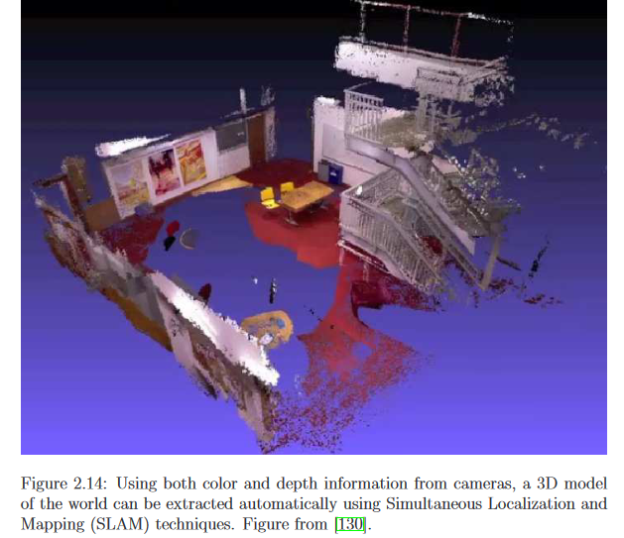

6.Matched Motion
The most basic operation of the VWG is to maintain a correspondence between user motions in the real world and the virtual world; (Figure 2.15). In the real world, the user’s motions are confined to a safe region, which we will call the matched zone. Imagine the matched zone as a place where the real and virtual worlds perfectly align. One of the greatest challenges is the mismatch of obstacles: What if the user is blocked in the virtual world but not in the real world? The reverse is also possible.
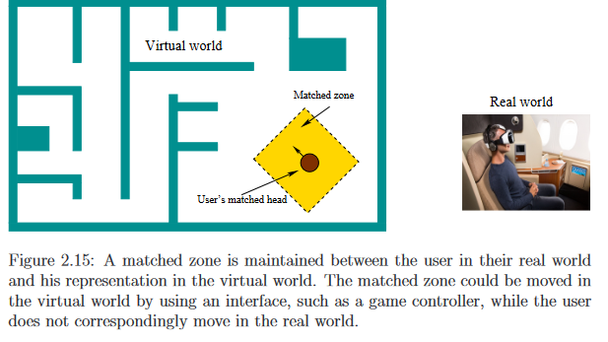
In a seated experience, the user sits in a chair while wearing a headset. The matched zone in this case is a small region, such as one cubic meter, in which users can move their heads. Head motions should be matched between the two worlds. If the user is not constrained to a seat, then the matched zone could be an entire room or an outdoor field. Note that safety becomes an issue because the user might spill a drink, hit walls, or fall into pits that exist only in the real world, but are not visible in the virtual world. Larger matched zones tend to lead to greater safety issues. Users must make sure that the matched zone is cleared of dangers in the real world, or the developer should make them visible in the virtual world.
7.User Locomotion
In many VR experiences, users want to move well outside of the matched zone. This motivates locomotion, which means moving oneself in the virtual world, while this motion is not matched in the real world. Imagine you want to explore a virtual city while remaining seated in the real world. How should this be achieved? You could pull up a map and point to where you want to go, with a quick teleportation operation sending you to the destination. A popular option is to move oneself in the virtual world by operating a game controller, mouse, or keyboard. By pressing buttons or moving knobs, yourself in the virtual world could be walking, running, jumping, swimming, flying, and so on. You could also climb aboard a vehicle in the virtual world and operate its controls to move yourself. These operations are certainly convenient, but often lead to sickness because of a mismatch between your balance and visual senses.
8.Physics
The VWG handles the geometric aspects of motion by applying the appropriate mathematical transformations. In addition, the VWG usually implements some physics so that as time progresses, the virtual world behaves like the real world. In most cases, the basic laws of mechanics should govern how objects move in the virtual world. For example, if you drop an object, then it should accelerate to the ground due to gravitational force acting on it. One important component is a collision detection algorithm, which determines whether two or more bodies are intersecting in the virtual world. If a new collision occurs, then an appropriate response is needed. For example, suppose the user pokes his head through a wall in the virtual world. Should the head in the virtual world be stopped, even though it continues to move in the real world? To make it more complex, what should happen if you unload a dump truck full of basketballs into a busy street in the virtual world? Simulated physics can become quite challenging, and is a discipline in itself. There is no limit to the complexity.
In addition to handling the motions of moving objects, the physics must also take into account how potential stimuli for the displays are created and propagate through the virtual world. How does light propagate through the environment? How does light interact with the surfaces in the virtual world? What are the sources of light? How do sound and smells propagate? These correspond to rendering problems, for visual and audio cases, respectively.
9.Networked experiences
In the case of a networked VR experience, a shared virtual world is maintained by a server. Each user has a distinct matched zone. Their matched zones might overlap in a real world, but one must then be careful so that they avoid unwanted collisions. Most often, these zones are disjoint and distributed around the Earth. Within the virtual world, user interactions, including collisions, must be managed by the VWG. If multiple users are interacting in a social setting, then the burdens of matched motions may increase. As users meet each other, they could expect to see eye motions, facial expressions, and body language.
10.Developer choices for VWGs
To summarize, a developer could start with a basic Software Development Kit (SDK) from a VR headset vendor and then build her own VWG from scratch. The SDK should provide the basic drivers and an interface to access tracking data and make calls to the graphical rendering libraries. In this case, the developer must build the physics of the virtual world from scratch, handling problems such as avatar movement, collision detection, lighting models, and audio. This gives the developer the greatest amount of control and ability to optimize performance; but the implementation would be difficult.
In some special cases, it might not be too difficult. For example, in the case of the Google Street viewer the “physics” is simple: The viewing location needs to jump between panoramic images in a comfortable way while maintaining a sense of location on the Earth. In the case of telepresence using a robot, the VWG would have to take into account movements in the physical world. Failure to handle collision detection could result in a broken robot (or human!).
At the other extreme, a developer may use a ready-made VWG that is customized to make a particular VR experience by choosing menu options and writing high-level scripts. Examples available today are OpenSimulator, Vizard by World-Viz, Unity 3D, and Unreal Engine by Epic Games. The latter two are game engines that were adapted to work for VR, and are by far the most popular among current VR developers. The first one, OpenSimulator, was designed as an open-source alternative to Second Life for building a virtual society of avatars. As already stated, using such higher-level engines make it easy for developers to make a VR experience in little time; however, the drawback is that it is harder to make highly original experiences that were not imagined by the engine builders.

Key Elements of Virtual Reality Experience
The key elements in experiencing virtual reality are a virtual world, immersion, sensory feedback (responding to user input), and interactivity.
Key Element 1: Virtual World
A virtual world is the content of a given medium. It may exist solely in the mind of its originator or be broadcast in such a way that it can be shared with others.
We can refer to the script of a play as merely the description of a play. When that description is brought to life via actors, stage sets, and music, we are experiencing the play's virtual world. Similarly, a computer- based virtual world is the description of objects within a simulation. When we view that world via a system that brings those objects and interactions to us in a physically immersive, interactive presentation, we are experiencing it via virtual reality.
virtual world -1. an imaginary space often manifested through a medium.
2. a description of a collection of objects in a space and the rules and
relationships governing those objects.
Key Element 2: Immersion
One definition of VR can be
“Immersion into an alternate reality or point of view.”
This definition acknowledges the possibility of perceiving something besides the world you are currently living in in two ways: you can either perceive an alternate world or the normal world from another point of view.
An alternate world might be a representation of an actual space that exists elsewhere, or it could be a purely imaginary environment. Alternate worlds are often created in the minds of novelists, composers, and other artists and creative individuals.
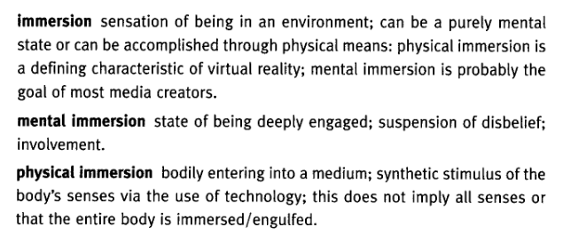
Key Element 3: Sensory Feedback
Unlike more traditional media, VR allows participants to select their vantage point by positioning their body and to affect events in the virtual world. These features help to make the reality more compelling than a media experience without these options.
Sensory feedback is an ingredient essential to virtual reality. The VR system provides direct sensory feedback to the participants based on their physical position. In most cases, it is the visual sense that receives feedback, although virtual reality environments do exist that display exclusively haptic (touch) experiences. Achieving immediate interactive feedback requires the use of a high-speed computer as a mediating device.
In order to base the sensory output of the VR system on the position of the participant, the system must track their movement. A typical VR system will track the head of the participant and at least one hand or an object held by the hand. Advanced systems may track many of the major body joints.
Key Element 4: Interactivity
For virtual reality to seem authentic, it should respond to user actions, namely, be interactive. The classic computer games The Oregon Trail, Adventure, and Zork render their worlds via text description. Each world responds to commands typed by the player, giving the player the sense of being involved with these worlds. The player interacts with objects, characters, and places in these imaginary worlds. The medium of authored, text-based interactive worlds is now often referred to as interactive fiction (IF).
The ability to affect a computer-based world describes one form of interactivity. Another form is the ability to change one's viewpoint within a world.
Interactive fiction can be defined in terms of the user/player's ability to interact with a world by changing locations, picking up objects and setting them down, flipping switches, and so on. Virtual reality is more closely associated with the ability of the participant to move physically within the world, obtaining a new vantage point through movements of the head.
The collaborative environment is an extension of the interactive element and refers to multiple users interacting within the same virtual space or simulation. Users can perceive others within the simulation, allowing for mutual interaction. The users' representations are referred to as their avatars.
Combining the Elements
Taking all of these ingredients into account yields the more suitable definition(by Sherman and Craig):
virtual reality a medium composed of interactive computer simulations that sense the participant's position and actions and replace or augment the feedback to one or more senses, giving the feeling of being mentally immersed or present in the simulation (a virtual world).

AREAS OF APPLICATIONS OF VIRTUAL REALITY

The areas of applications of Virtual reality includes
1. Business and Manufacturing.
2. Science Applications
3. Medical Applications
4. Education Applications
5. Public Safety and Military Applications
6. Art
7. Entertainment Applications

1.Business and Manufacturing
There are many ways in which VR has been applied in business.
Product development
- VR can be used for virtual prototyping, which is the use of a computer to simulate a design of an object or system. Examples of virtual prototyping that have successfully incorporated VR include efforts by Caterpillar Inc. and General Motors Corp. Another interesting example includes experimental studies performed by DaimlerChrysler on the perceptions of customers to possible car interior designs.
- VR has the potential to be used as a tool in which a product is designed. This is demonstrated in the collaborative work between Nalco Fuel Tech and Argonne National Laboratory, where optimal placement of fuel injectors within a boiler can be determined via an immersive, interactive tool.
- Work has also been done by Lockheed/Martin to create a ship-designing tool that allows immersed participants to manipulate designs, with consequences such as pipe relocation performed automatically.
- VR has also been tested as a means for improving productivity during the manufacturing process. In particular, The Boeing Company created an experimental augmented reality system that shows a human assembler of aircraft wire-bundles where to place each wire, a step at a time.
Business Education
The use of VR as a training tool is spread across many fields. One notable example in the area of manufacturing is the training of assembly line procedures at Motorola University. Motorola found that VR benefits the learning process in three ways:
1) the virtual assembly line is much cheaper to create and duplicate than a physical practice line;
2) the computer version is easier to transport to other training centers;
3)the workers being trained are more highly motivated to work with the virtual assembly line than previous training methodologies.
Marketing
VR is sometimes used as part of a marketing strategy to demonstrate that a particular company or product is high tech, forward looking, or just plain cool. In this case, getting people to remember and talk about the product is the goal. As a new, exciting, and often talked about technology, virtual reality has been used several times as part of advertising campaigns. Television advertisements include those by Honda, Starburst, and Bubble Yum.
Virtual Reality gives the opportunity to advertisers of providing advertising that people want to participate in. One way in which this has been done was through the development of a specific VR game that relates to the company or product. This game was then taken to several venues (stores, trade shows, etc.), where people literally stood in line to experience the advertisement. Since lines often attract attention to themselves, the effect often snowballs, bringing more people to see the message.
Example: marketing Cutty Sark scotch,the Fraunhofer Institute for Computer Graphics (IGD) done a project for a Swiss bank to help draw attention to a new bank card they were introducing.
The VR application (game) itself might be a good piece of advertising. However, because of the excitement, there are usually several people queued up to take their turn. This presents another opportunity to communicate with potential customers. While in line, people can be presented product information in more traditional ways as well as provide information back to the company by filling out marketing questionnaires. Most people do not object to providing this form of “payment ” to try the experience. Examples of this include Virtuality for the Ford Galaxy and Matsushita for Kitchen and House products.
Other and future usage of VR in business and manufacturing
- Some research that is already underway includes the usage of VR as a tool for studying production flow, especially for factory floor machine layouts. Research has also been done on maintenance analysis of product designs, taking advantage of the LBE game BattleTech and using a simplified version of the experience as part of a team-building effort.
- Another area in which VR has been used extensively includes collaborative work environments, allowing workers to more easily work with others who might be at a remote site. An example of this is the Virtual Director application.
- Other potential areas for applying VR to business and manufacturing include the visualization of business information and farming data.
- Business visualization is currently a growing area of research among visualization experts, and has expanded into the medium of VR. Similar techniques will also be useful for people who need to access large archives of business data. A spatial organization of information can be helpful in being able to sort through such data. VR can provide a means of allowing a person to spatially experience a database. Spatial data in VR can be achieved by extending typical GIS representations into 3D, and also by developing completely new representations.
- Farming has become increasingly high tech. Many farms now use the global positioning systems (GPS), combined with soil analysis techniques, to apply specific fertilizers/pesticides for certain locations in the field. This and other information can be transferred to a VR visualization tool for analysis and/or telepresence applications for farmers.
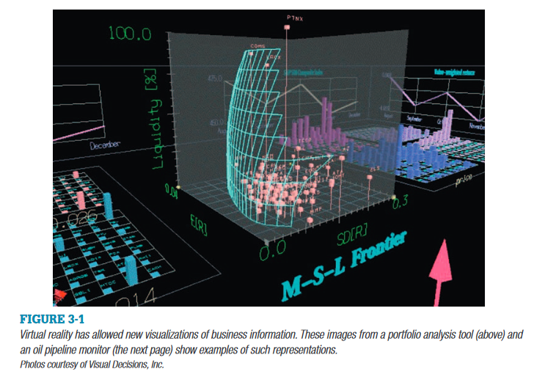
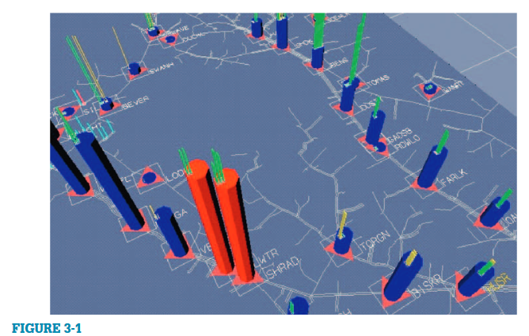

2.Science Applications
Scientists have used virtual reality to interface with their work in three primary ways: the visualization of observed and simulated data, exploration of places that are difficult to travel to, and direct interaction with simulations of physical systems.
■ Scientific visualization
■ Scientific exploration
■ Physical system simulation and interaction
Scientific visualization
- Scientists have applied virtual reality to scientific visualization in a number of fields.
- Computational fluid dynamics allows the scientist to simulate flow under various conditions. The ability to visualize flow allows the scientist to better understand the fluid’s interaction with objects in the environment (such as the flow of air over a wing, or blood through an artery). Because most flow is three dimensional, the three-dimensional virtual interface is often advantageous.
- The Virtual Windtunnel application was a pioneering virtual reality application in the field of fluid dynamics.Prior to the existence of the Virtual Windtunnel, experiments such as studying the airflow over a wing were carried out in actual wind tunnels.
- The buildings we live in are three dimensional in nature. Understanding their structural properties allows engineers to design and build safer buildings that are able to stand under heavy wind conditions, earthquakes, etc. Finite element models of structures, beams, automobile fenders, etc., can be visualized in virtual reality and allow the scientists to understand their behavior under varying conditions.
- Chemists, biochemists, and others are interested in how atoms and molecules interact. The ability to visualize those interactions is a powerful tool in understanding basic reactions, drug design, properties of materials, and much more.
Exploration
- Consider space exploration. NASA has spent billions of dollars, as well as the cost of lost lives, to allow scientists to gather data from space. However, the benefits from such exploration have been immense. Virtual reality and related technologies such as telepresence are allowing scientists to explore remote areas from the safety and comfort of their own laboratories.
- These technologies are also allowing scientists to explore areas that have never been explored before, such as the bottom of the ocean, within nuclear waste dumps, and other areas that are hostile to human life.
- The BayWalk application was created primarily as a scientific visualization and collaboration tool for exploring the results of a complex computational science simulation. In the computational model, the three-dimensional bay was divided into 4000 volumetric cells or “bricks.” The simulation calculates flow information and the presence of certain substances (chlorophyll, salinity, dissolved oxygen, nitrogen and phosphorus) throughout the bay over time.
Physical system simulation and interaction
- In many cases it is advantageous to be able to visualize and manipulate objects in a simulated or real system. For example, in the GRIP application scientists are able to reach out and physically manipulate representations of molecules, and observe visually their interactions.
- In addition, the scientist is able to feel the forces between molecules via a haptic interface.
- Another example of physical simulation and interaction is the Air Force solar system modeler, which allows scientists and engineers to observe locations of planets and other celestial objects, as well as satellites and other man-made objects from various perspectives, and at various times in the past and in the future.
- There is also the scientific visualization application Crumbs which has found many applications in the medical field.
- Some tools may find use in the fields of anthropology, archeology, and any study of natural phenomena, such as Sandia’s RAPTOR study.
- Another path for visualization in virtual reality is to enable current visualization tools to exploit the new capabilities of virtual reality. This allows scientists who are already familiar with visualizing their data using common software packages to take advantage of the immersive VR environment. This process includes packages such as AVS, COVISE, and SciRun adapted to CAVE environments.

3.Medical Applications
Virtual reality is being used in a variety of ways in the medical field ranging from drug design, to empathy training to Phobia treatment.
The application areas include:
■ Training
■ Scientific visualization
■ Preoperative planning
■ During-operation assistance
New application areas continue to emerge. Virtual reality is being applied in dentistry, otolaryngology (ear, nose, and throat), balance dysfunction, training for patient interviews, endoscopy, and other fields. The medical community is sufficiently interested in virtual reality that there is a conference specifically dedicated to VR in medicine. The “Medicine Meets Virtual Reality” (MMVR) conference provides a venue for interested participants to exchange ideas, view the latest products, and publish important findings. The MMVR conference has been active for over 15 years.
Training
The BDI Surgical Simulator is a medical training tool that uses force feedback to give life-like responses to a specific surgical procedure. The specific goal of the Surgical Simulator is to re-create the experience of doing “ end-to-end anastomosis ”— the task of suturing tube-like organs together. This task was chosen partially because anastomosis is found in many surgical procedures involving various organ systems, such as blood vessels, esophagus, colon, and bile ducts. BDI designed the simulator to accommodate these various organs by providing an adjustable set of parameters, such as tube diameter, tissue stiffness, surface texture, surface friction, needle piercing forces, and so forth. Models of the different tissues and tube organs are created to both look and feel like the real thing.
Actual medical instruments such as forceps and needle holders are attached to force-feedback devices. The end result is that the student can feel their interactions with virtual organs. They can sense the elasticity and stiffness of tissue and can sense when a needle penetrates an organ.
In conjunction with the Surgical Simulator, BDI has also developed a simpler system created to measure task performance on specific actions such as time to completion, needle placement accuracy, tissue surface damage, tangential tearing force, and others.
A celiac plexus block is a medical procedure for injecting a drug in a particular region within the torso of a patient. This procedure is carried out by inserting a needle into the back of a patient who is lying on their abdomen, and injecting a drug in the appropriate location. Finding the
precise location of the needle inside the body is a difficult skill to learn. The physician uses a combination of their knowledge of anatomy with periodic x-ray views displayed on a fluoroscope.
The Celiac Plexus Block Simulator attempts to mimic as much of the actual procedure as necessary to convey a realistic sensation of performing the operation on a human patient. During the simulation session, the physician can use the integrated “virtual fluoroscope” to display x-ray views of the patient, including the location of the needle on the computer monitor.
In addition to the haptic and visual sensory displays, the Celiac Plexus Block Simulator also provides aural feedback cues. In particular, if the user attempts to push the needle into a bone with forces that would cause pain in a patient, the system triggers the playback of a digital recording of the sound of a cry of pain.
Dorothy Strickland hypothesized that VR would provide a safe learning environment for children with autism, and that a number of the special requirements for learning tools for these children can be met by virtual reality. This would be particularly beneficial for tasks that can be dangerous to learn in the real world, such as knowing what to do, and more importantly, what not to do, at street intersections.
Strickland compiled a list of features that should be included in an environment for teaching children with autism .Each of these features matches abilities of virtual reality, strengthening the possibility of the usefulness of VR for this task. Her list of features include:
■ Controllable input stimuli
■ Modification for generalization
■ Safe-learning environment
■ A primarily visual world
■ Individualized treatment
■ Learning with minimal human interaction
■ Vestibular stimulation

We can integrate virtual reality technology to aid patients in overcoming their fears. Experts started this by addressing acrophobia (the fear of heights), and then expanded their work to include aerophobia (the fear of flying) and other disorders.
4.Education Application
Virtual reality is currently being used or tested in a variety of formal and informal educational settings. Formal settings include elementary school, secondary school, universities, etc. Informal settings include museums, zoos, libraries, and other similar venues.
1)
Researchers at George Mason University, in collaboration with the University of Houston, developed an experimental test bed in which they studied the use of three-dimensional virtual reality for teaching three-dimensional concepts. As an experimental platform they developed three worlds for teaching concepts of physics and chemistry. NewtonWorld helps students explore concepts of Newtonian mechanics. MaxwellWorld provides an interactive space for studying concepts of electromagnetic fields.Holding a tracked wand, students create and place electric charges in space, producing representations of the electric forces, fields and flux. PaulingWorld is focused on interactions between molecules. Collectively, the research is called Project ScienceSpace.
VR will be useful for science education because it addresses four vital components of the nature of learning:
■ The novelty of VR draws the students ’ attention.
■ The computer worlds can be used to generate meaningful representations.
■ Information can simultaneously be presented in a variety of forms.
■ Students can learn by doing, using “reflective inquiry.”
2)
MaxwellVU is primarily concerned with giving students physical insights into the fundamental equations governing electromagnetics, the so-called Maxwell equations. The MaxwellVU suite consists of five separate applications, one each to support understanding of each of equations Gauss’s Law (Electric Field), Gauss’s Law (Magnetic Field), Faraday’s Law, Ampere’s Law and Coulomb’s Law.
3) Virtual Pompeii is a walkthrough recreation of Pompeii as it existed before Mount Vesuvius erupted in AD 79. Rather than merely viewing photographs of an archeological dig side by side with a few artifacts from the dig and a drawing of how the structures were laid out, with Virtual Pompeii viewers can journey through the city and witness the society and culture. The focus of the virtual site is the Pompeian theater complex. The complex consists of the Large Theater, ruins of the Temple of Hercules, the Triangular Forum, and the Temple of Isis. These structures and other nearby streets and buildings are included in the Virtual Pompeii experience. Participants can explore the walkways, sculptures, murals, courtyards, and structures as they existed long ago.
4)
Few virtual reality applications have focused on teaching about the social behaviors of the animal kingdom. The Virtual Reality Gorilla Exhibit was a joint project between Georgia Institute of Technology’s Graphics, Visualization, and Usability Lab (GVU) and Zoo Atlanta. The project had an overall goal of educating middle school children about gorilla interaction, vocalizations, and social structures. Because gorillas are an endangered species, gorilla conservation education is becoming increasingly important. The application includes a model of the gorilla habitat (modeled geometrically) and gorilla agents (modeled geometrically, behaviorally, and sonically). Real-world images and sounds were incorporated into the experience as texture maps and sound samples to enhance the realism of how the world is presented.
5)
Researchers Lyn Mowafy and Jay Pollack led the research project titled Train to Travel which is a VR system to train handicapped individuals to use the bus system. The virtual world was created by obtaining maps of the Dayton bus system, and using digitized photographs to create realistic-looking landmarks along the course of the bus in the parts of the trip.
6)
The Learning Sites Fortress of Buhen project is one example of enabling travel to a place that is no longer accessible. A computer-generated agent modeled as an ancient Egyptian scribe acts as a tour guide to show the participant around the virtual world.
One benefit of utilizing the medium of VR for virtual travel is the ability to hold different interpretations of the site within a common context. Information about materials collected by, and owned by, different entities can be merged together into a single form.
Storage in digital form also allows for the inclusion of annotations tied directly to the data, so whenever the data is accessed, a list of notes can be summoned automatically. Digital information is also generally more transportable, and some formats allow it to be moved easily from one type of machine to another. Digital information does not gradually decay as the original source material does.
Two other benefits arise from the ability to virtually travel. Sites or artifacts that cannot be visited or touched due to religious or other restricted access reasons can often be made accessible to the public in digital form. Also, the ability to telecommute becomes a possibility for some archaeologists. A lead archaeologist or expert on some particular topic can be consulted on various issues by archaeologists physically at a dig site.
7)
Virtual Mobility Trainer (VMT) help to train and motivate disabled children in the use of wheelchairs. In the Virtual Mobility Trainer system, children wear a head-mounted display to view the virtual world, and sit in a conventional wheelchair mounted on rollers with motion sensors. The
child operates the wheelchair with its normal controls and the platform calculates movement through the virtual world by measuring the movement of the wheels.
Three initial virtual worlds were constructed in which students could practice specific tasks:
■ An empty VR training world
■ A large abstract space with interesting objects
■ A model of a real-world crosswalk

5.Public Safety and Military applications
Virtual reality is used to help save lives indirectly by training firefighters, police, and military personnel, as well as in educating the general public, in how to respond in various dangerous situations ranging from natural disasters such as tornados and earthquakes to acts of terrorism.
Equipment Operation Training
Much like commercial pilots learning to fly a Boeing 747 in a flight simulator, military pilots can learn how to fly an F-117A, and also combat maneuvers under military conditions. An added element is the ability to practice specific missions such as a particular bombing mission.
Situational training
In many fields, split-second timing is crucial, so one doesn’t have time to make plans and rehearse for the action (e.g., firefighting); in other situations, while the action might require split-second choices, there is time to prepare for the particular situation. So, for firefighting, it is beneficial to learn about how to handle many, unrehearsed situations, whereas for military or hostage rescue actions, one can spend time to prepare for a specific operation. Of course, in many cases, the same application could be used for both general training and for a specific operation (e.g., the VRaptor hostage rescue).
Mission planning
A specific type of VR training that can be applied to any kind of route planning or maneuver planning can be referred to as mission planning. This can range from presurgery planning to the practice of a rescue maneuver. It could also include the repair of an expensive piece of equipment(eg: astronauts planned for and practiced repairing the Hubble Space Telescope.).
Why should a soldier endanger their life by being in a tank on the battlefield when through the use of telepresence they can perform the same operation from the safety of a remote location? The picture below shows a robot equipped with a camera, shotgun, microphone, speaker, and other facilities to assist in seeking out villains in hostage situations while the officer remains safely out of harm’s way.
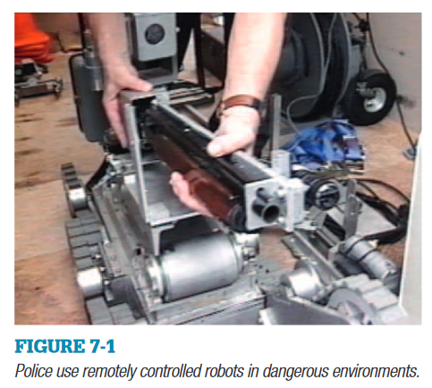

Augmented reality has become more prevalent in military and public safety applications. As firefighters enter a burning building, they may have additional information displays that indicate where they are in the building floor plan, where volatile materials are stored, or where the home base indicates that victims are stranded in the building.
- The overall goal of Virtual Environment Technology for Training Project (VETT) is to research methods of training using VR technology that will provide cost savings and/ or improved learning. The Officer Off the Deck (OOD) application provides a simulation in which a naval officer can rehearse navigating a submarine safely into port. The task is interesting in several ways. One is that the task can seldom be rehearsed outside of the virtual environment. Additionally, the ramifications of a failure in the task can be disastrous in terms of safety and expense.
- One of the NRL’s (Naval Research Laboratory) research projects has been to explore the potential effectiveness of VR as a tool for training shipboard firefighting techniques, mission planning, and rehearsal. To create the virtual training environment, portions of the
Shadwell(decommissioned ship) have been modeled at full scale in the VR environment. The application developers created a realistic model of the ship utilizing photographic texture maps to provide surface gradients for the bulkheads and decks. Objects that could be used in the firefighting procedure were modeled as 3D virtual objects. It also contained a simulated fire, complete with smoke plume and ambient smoke The fire-and-plume display was implemented as a loop of texture maps on a viewer-facing polygon. The textures were created using video of an actual fire. Ambient smoke was created using the atmospheric effects of the Silicon Graphics Reality Engine 2.
- The Virtual Reality/Intelligent Simulation (VR/IS) team at Sandia National Laboratories created a system for VR Assault Planning Training or Rehearsal (VRaptor). VRaptor is a system that provides the capability for end user instructors to create scenarios for situational training including hostage rescue. The virtual world of the hostage scenario consists of a room with furnishings, the avatar of the trainee, and virtual actors represented as human forms. The instructor can script the reactive behavior of the virtual actors. Sound effects (sounds of the stun grenade and gunshots) help increase the realism of the event and augment the mental immersion felt by the participant.
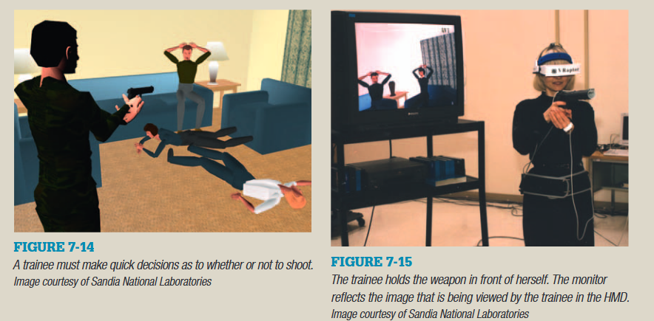
- VR can also act as a Space Walk Trainer for manned space missions. The objects modeled for the HST (Hubble Space Telescope) training application included all the objects with which the astronauts would interact. The design team constructed a computer model of the HST, the payload bay and fixtures used for transporting replacement systems into orbit, and the components that would be replaced or serviced during the repair and maintenance mission. The rest of the Space Shuttle components (that would not be seen during this task) were not modeled. Objects were created using the engineering drawings of the real-life counterparts, for more accurate representation.
- The potential benefits of computer mediated warfare training are the ability to bring together units physically located in disparate regions of the globe, and to do exercises using a far less dangerous, and environmentally disruptive methodology.

6. ART
Four categories of art applications include:
- design and sketching,
- exploration of the medium,
- empathetic experiences, and
- exploration of the human condition.

Design and sketching

- The use of VR for design and sketching allows one to create works of art while immersed in a virtual reality environment.
- ShadowLight allows participants to create and place arbitrary polygons, paint and texture them, group objects, and use lighting effects, and provides many other drawing tools. Ie students can sketch their ideas, at full scale, while immersed in the object they are creating.
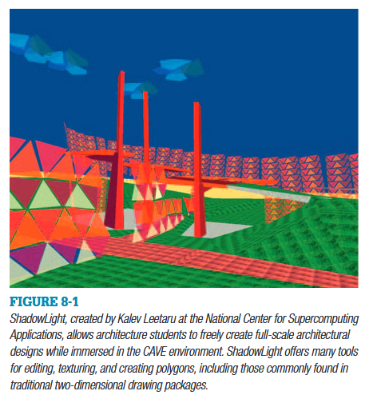
- The Body Language User Interface (BLUI), from the Arctic Region Supercomputing Center, allows participants to create very fluid sculpture while immersed in a CAVE or other projection VR device. BLUI offers a very intuitive way to create digital sculpture. The resulting sculptures can be experienced in VR, or they can be printed out using three-dimensional prototyping printers
- CavePainting from Brown University allows people to freely brush strokes of virtual paint in a VR environment to create very fluid, three-dimensional virtual worlds. The paintbrushes are the analog of paintbrushes in two-dimensional computer paint programs.

Exploration of the medium
- It consists of artworks that do something different in order to appraise the end result.
- In the mid 1970s, Myron Krueger developed walk-in, computer mediated, interactive environments as part of his Videoplace experience. Within Videoplace the position and movement of participants resulted in changes of the images projected on the walls of the space.
- Mark Bolas’ Flatlands example reflects the expanded scope of VR over the 2D plane. In his application, the viewer is positioned in a small cubical room, and can see a representation of Mondrian’s painting “Composition with Line” on two of the walls. However, the two representations differ. One places all the lines of the virtual painting in the planar field. The other representation relocates some of the lines farther away from the viewer than others. The more the viewer moves from the center of the small room, the more they can see the
three dimensionality of the second representation.
- Example VR applications that fall mostly in the realm of media exploration are Placeholder, created by a team by Brenda Laurel as well as Charlotte Davies’ Osmose. Osmose was meant to provide participants (or “immersants,”) an experience of solitude. Unlike experiences that pit one participant against another, Davies strove to provide an environment that would allow participants to commune with themselves, to explore their inner self, questioning their everyday assumptions about being in the world. Unlike many other VR experiences, the goal of Osmose is not to accurately document or photorealistically portray particular aspects of the natural world. Rather, it is to convey a sense of the ethereal or a sense of being sentient and embodied in a living flowing world.
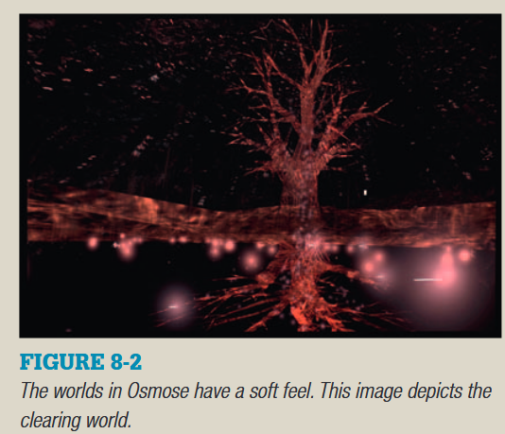

Empathetic experiences

Empathetic experiences are those that use the medium to put the participant “in someone else’s shoes.” By following the progression of one character, the reader/viewer is guided to strongly identify with the character, and the experiences they are going through.
The narrative of Rita Addison’s Detour: Brain Deconstruction Ahead is not as imposing as most novels and motion pictures, but the ability to empathize with the artist’s own personal life experience is very strong. Detour: Brain Deconstruction Ahead (Detour: BDA) is a VR experience that attempts to communicate the impact of perceptual anomalies that result from brain trauma.
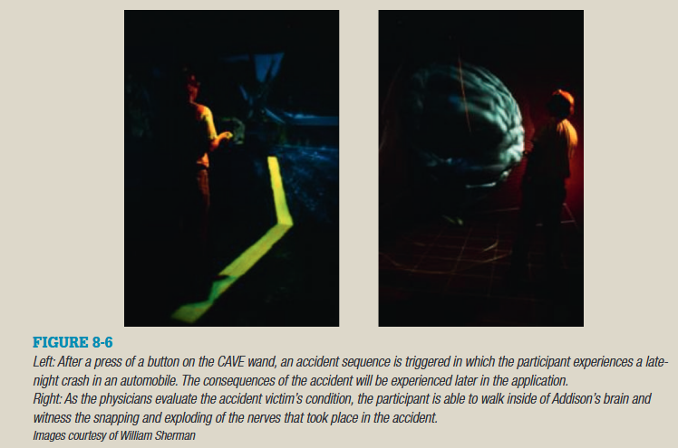
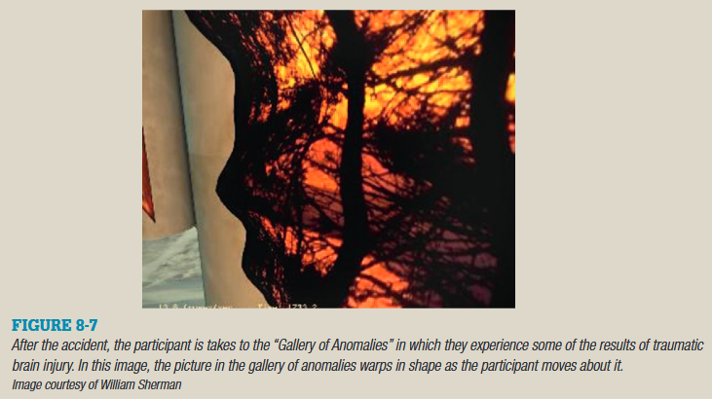

Exploration of the human condition
Subjects such as exploration of the human condition include those works that focus on how we
as humans relate to one another. These works can help us explore relationships with both our contemporary terrestrial cohabitants, and those that have gone before.
Two examples of such virtual reality experiences are Cirincione et al. The Imperial Message, and Benjamin Britton’s VR Caves of Lascaux experience.
In The Imperial Message the participant is put in the situation of progressing from the world of the individual, to the world of the emperor. Along the way they confront many of the conflicts between the state, and the individual .
In The VR Cave of Lascaux experience, the participant explores a 3D representation of a real space, but at the same time is made aware that the caves are a place shared by an ancient community, a recent community, the modern world, and even those whom have come to share the VR experience together.
The VR Cave of Lascaux is an interesting combination of science and art. The application is an artistic recreation of the cave of Lascaux, but while many aspects of the experience are scientifically accurate, the goal is not scientific realism but rather a way to experience the magic of the cave. The application is typically experienced in a head-mounted display, and navigated with a six-degrees-of-freedom input device.
7.Entertainment Applications
Games
Extending games into the medium of virtual reality offers many new opportunities for game play. VR offers the opportunity for true immersion into the game with up to a full field-of-regard, stereoscopic imagery, and natural user interfaces such as allowing the participant to physically jump rather than press a button on the controller to make their character jump. In general, traditional computer games operate from a second-person point of view (the participant is controlling their character that they see on the screen via some controller device). VR offers the opportunity for the game player to jump into the game and participate from the first-person point of view. To date, most VR applications operate from the first-person point of view with the notable exception of the MANDALA series of second-person point-of-view games.
Interactive Fiction
The idea behind any interactive fiction experience is that there is a story line that the participant can alter based on choices they make throughout the experience. In a printed (text) interactive fiction, the person may read a page, and then go to one page if they choose to answer a dilemma one way, or a different page if they answer it another way. With interactive fiction, there is the potential for each participant to have a different experience with the activity, and also for any given participant to have a different experience the next time they play it. One early, inspirational example of interactive fiction in the medium of virtual reality is The Thing Growing, created by Josephine Anstey and Dave Pape. Throughout the experience, there is a character that suggests things for the participant to do. The participant can choose to do them, or to ignore the character and do something else. In general in this application, if they ignore the character, the character gets more adamant and demanding of the participant. The experience culminates in a dilemma of whether to
kill or not to kill with differing consequences.

Creative Expression
Virtual reality offers the opportunity to freely create, sketch, and imagine in a three-dimensional world. In the simplest sense, one can use a three-dimensional drawing program to free oneself of the constraints of the two-dimensional world of paper or computer monitor. VR applications like BLUI allow one to create flowing, colored shapes in a darkened virtual world.
Entertainment Production
In addition to virtual reality applications being used by participants as entertainment in its own right, virtual reality has also been used as a tool for creating media (whether the media is virtual reality, music, film, or others) that is then experienced by the participant. For example, virtual reality applications can be used as a tool for aiding in the placement of three-dimensional sounds for playback in a standard surround-sound environment.
- Walt Disney’s Aladdin Adventure VR attraction demonstrates several techniques of entertainment and storytelling within an interactive immersive medium. The VR experience is a computer-generated world with scenery and characters similar to those in the Disney feature film. “Guests” are given a task, or mission that fits the theme. They are then given a fixed amount of time to fly through the world of Agrabah and complete their mission. To accomplish the assigned task, the participant must interact with the characters, and navigate through several locations in the virtual world while riding on the familiar magic carpet.
- Virtuality Game Systems- The goal of Virtuality founder Dr. Jonathan Waldern and the Virtuality staff was to produce VR systems and experiences that were robust enough that they could be deployed in public spaces (and eventually homes) without requiring the venue operator or home user to be an expert in virtual reality or computer system integration.
Two basic arcade configurations are offered on which the games are played. Both use a head-mounted display, with the graphics and simulation performed on a PC system with special graphics accelerator cards.
In the stand-up system, the participant stands on a circular platform that also houses the computing equipment.A rail encircles the participant about waist high. This gives a limit to the distance the participant can physically walk, as well as something they can lean against or hold to maintain stability. The handheld prop is a 6-DOF tracked unit used for user input control (such as aiming and shooting, or activating something). Some games, such as the Winchester Trap Master, use specialized handheld props crafted to give a more realistic interface.
In the sit-down version, participants sit in a plastic pod with a bucket seat and a spoiler, giving it a carlike appearance. The armrests house the controllers that the participant uses to interact with the game.
The virtual world experiences appear as three-dimensional cartoon-like environments. The participant sees an avatar of the controller unit when appropriate to the game. For example, a rifle, a hand holding a pistol, or even the front of their vehicle. In multiplayer experiences, players see each other either as a human (standup platforms) or their vehicle (sit-down platforms).
- The Virtual Director application (VirDir) is a virtual reality tool that is a navigation and camera choreography tool for virtual environments as well as the desktop and acts as an aid in creating camera moves for computer graphics (CG) animations in multiple formats. The tool surrounds the user with a three-dimensional virtual world, and gives them a virtual camera with which to choreograph the camera’s position in the virtual world. Voice input combined with gestures allows the director great flexibility in interactively creating camera moves. While Virtual Director can be used for entertainment purposes, the original application for the tool was to aid in the creation of movies of computer graphics for scientific understanding and communication.
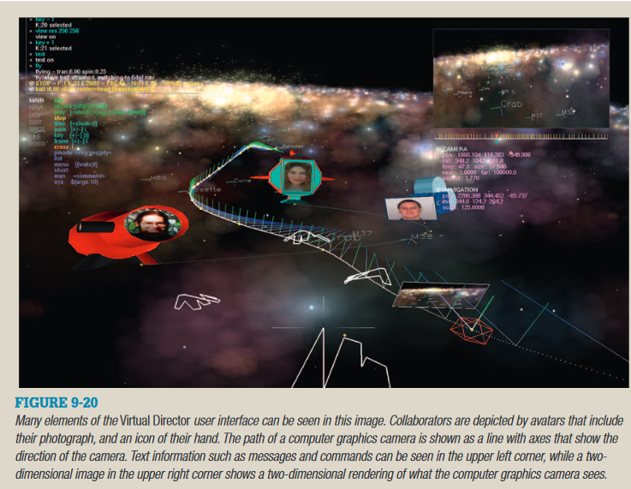
By creating multiple camera paths, camera path sequences can be created and edited. There are several possible sequence-editing constructs in the system, including:
■ Regular, in which the camera stays on one path
■ Priority, where the camera follows a master path, but can be overridden at any point in time by a higher priority move for brief parts.
■ Sequential, in which each camera path is executed in order, even if that means jumping back in time to begin the next sequence.
■ Edit list management, though not yet implemented, the future plans for Virtual Director include the capability of allowing any arbitrary sequence of paths and portions of paths to be strung together in a straightforward manner.

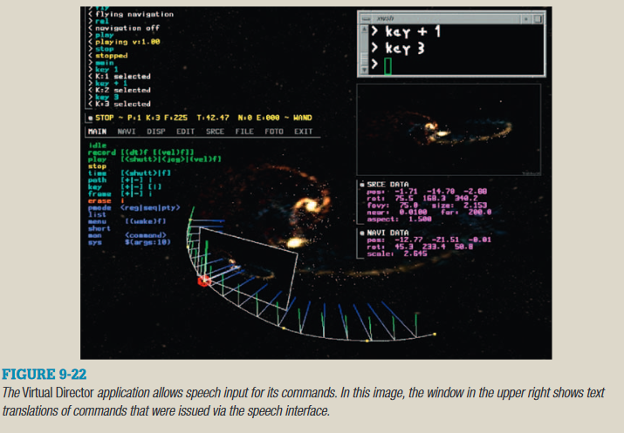
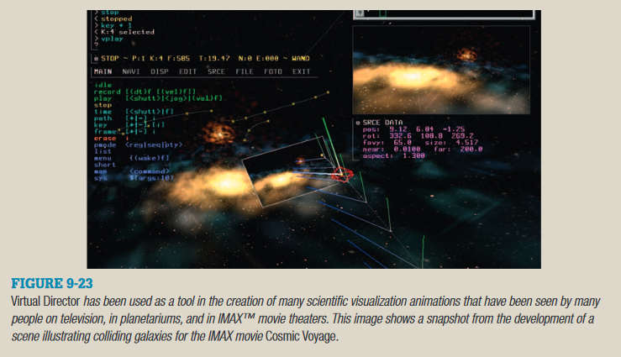

QUESTIONS
(3 marks each)
1. Write a brief note on Virtual Reality Systems?
2. List out the Application areas where Virtual Reality is used.
3. Define Virtual Reality.
4. Write about Augmented and Mixed reality.
5. What are Degrees of Freedom?
6. Explain the key elements of Virtual Reality experiences?(7 marks)

(14 marks each)
7. Explain about Virtual Reality Systems
8. Explain about Modern VR experiences.
9. Explain the areas of application of Virtual Reality
10. Explain the evolution of VR systems.
OR
How did we arrive to VR as it exists today. Explain?

